SMUSA Asset Loan Standing Order | Updated as of 28 Jan 2022

Asset Loan Standing Order

Loan Application Process
- All bookings are to be made at a maximum of 14 working days and a minimum of 7 working days prior to the requested loan date. Working days do not include weekends nor public holidays. Any request made outside of the abovementioned time period will not be attended to.

- All loan applications are to be submitted via the SMUSA Website through the attached

Google Form.

- Confirmations are made within 4 working days upon submission of a loan request.

- All emails received outside of working hours (Mon-Fri 8AM-8PM, excluding PH), will be attended to the next working day.

- SMUSA Operations Department reserves the right to cease operations during the Finals period, commencing from the week prior to Finals. Urgent cases shall be reviewed on a case to case basis, subjected to the team’s discretion.

- User bookings are only valid once the requestor receives a confirmation email reply from the SMUSA Operations Department.

- The loaner shall be entitled to make changes to the loan twice. These changes include time of collection/return, items to be loaned, etc. To facilitate any of the abovementioned changes, the loaner is to email to operations@sa.smu.edu.sg and cc a.operations@sa.smu.edu.sg. Communication of any changes via other means will not be attended to. Changes are to be made the latest 1 day before the loan date.

- The SMUSA Operations Department reserves the right to cancel the loan if there are any changes made after the stipulated timing

- The SMUSA Operations Department reserves the right to change the details of the bookings, at any point prior to and/or during the loan period, including but not limited to:

  - Refusal or cancellation
  - Collection and return timings
  - Requested inventory

Usage Terms
- All collections and returns are to be made at the SMUSA Bencoolen Storeroom, located on the left side of the Bencoolen MRT entrance at basement 1. The storeroom can be identified through a SMUSA logo pasted on the doors. Further information which includes pictures on the location of various storerooms, are stated on the SMUSA website.

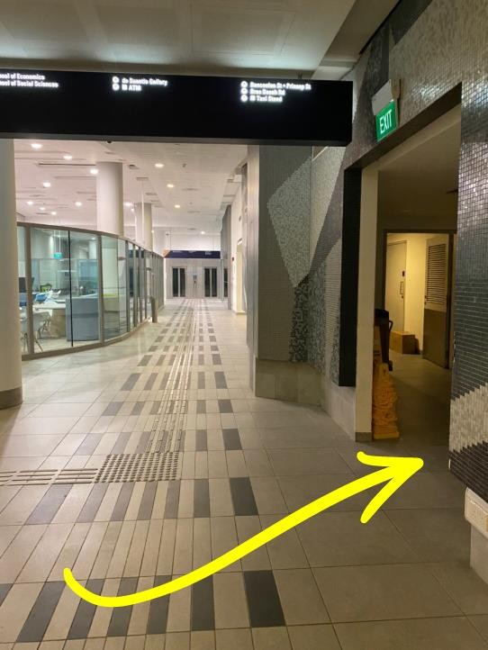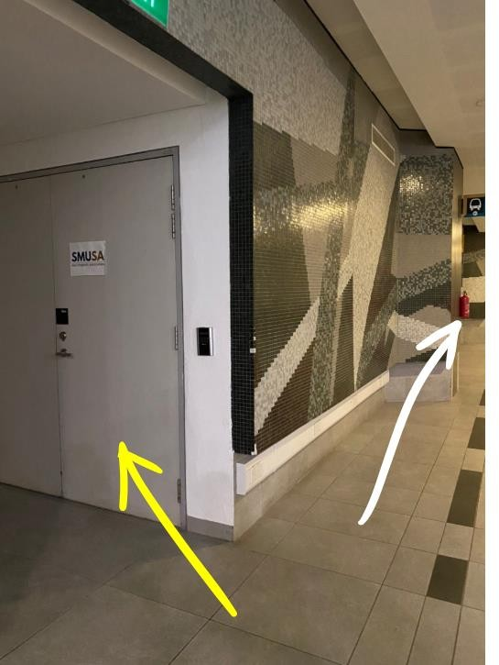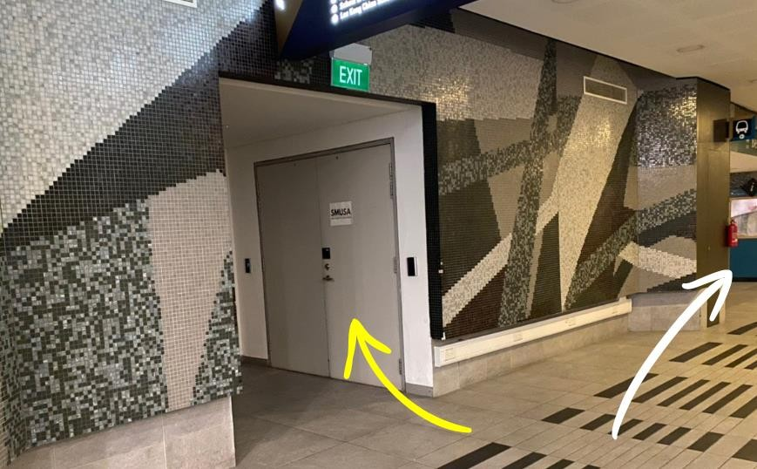
White Arrow – Bencoolen Entrance Yellow Arrow – SMUSA Store

- Assets loaned from SMUSA should always be in the possession of the requestor and
swapping of assets are strictly not tolerated.

- Assets are to be collected and returned according to the allocated collection and return timings, having taken into consideration the period of event.

- Assets are to be collected/returned during the 3 mass opening periods as indicated on SMUSA’s website. For the confirmation of the exact collection and return time, the loaner is to liaise with the appointed SMUSA Operations Representative via Telegram. The Telegram handle of the representative will be provided in the confirmation email.

- The SMUSA Operations Department should be notified of all late comings at least 1 hour before the appointment. A 15 - minute grace period shall be given in lieu of such notice. The SMUSA Operations Department shall reserve the right to cancel the booking should it exceed the 15 minutes grace period.

SMUSA Operations Department reserves the right to cancel the bookings of clubs who are late without notice exceeding 5 minutes.

- SMUSA Operations Department is not responsible for providing manpower and transportation of assets. This includes not granting the usage of trolleys of such.

- Assets are to be collected or returned under the facilitation of a SMUSA Operations representative unless otherwise instructed by SMUSA.

- Overnight storage is made at SMUSA Cage, located on the right side of the Bencoolen MRT entrance. SMUSA Operations Department shall not be held liable for any damage or loss of equipment that arise from storing during the loan period. Storage is strictly limited to the items on loan.
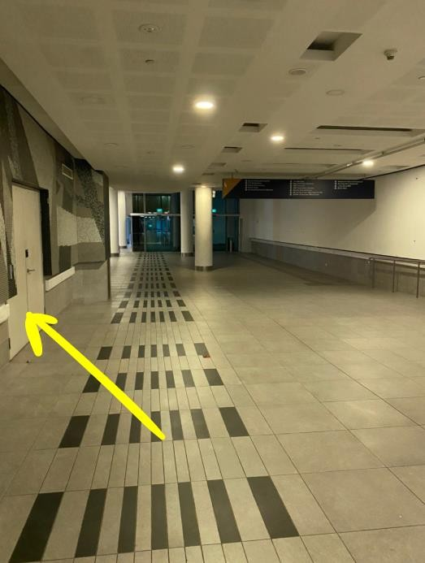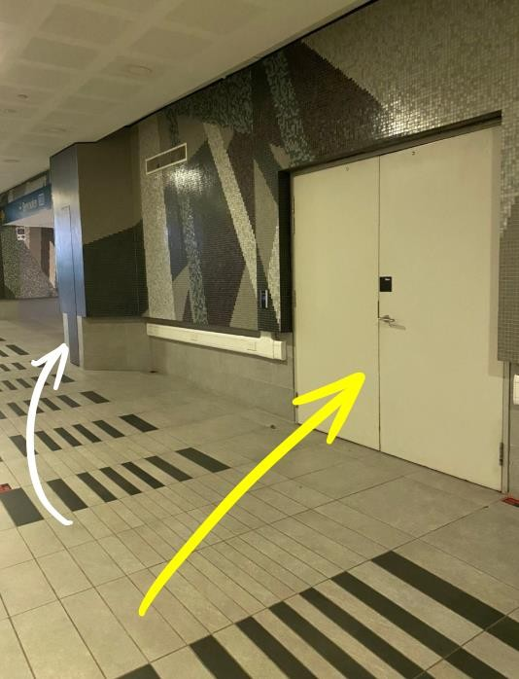

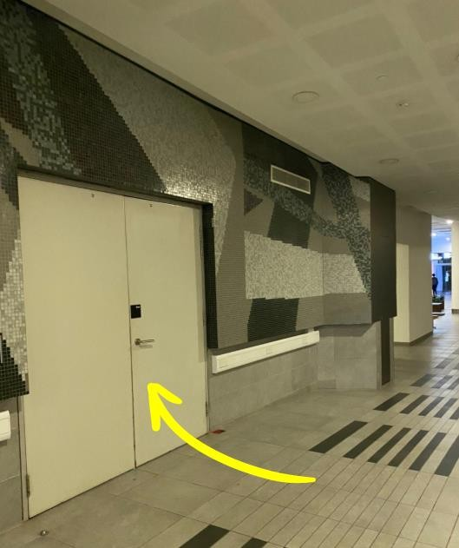
White Arrow – Bencoolen Entrance Yellow Arrow – SMUSA Cage

- Lack of compliance to these usage terms shall entail penalties as follows:

  - 1st offence: Email warning;
  - 2nd offence: Lower priority for their next request;
  - 3rd offence: Loan requests shall not be entertained;
  - Such penalties shall not extend beyond the current semester, inclusive of summer (Semester is defined as January – June, July – December)

- Assets are to be returned in their original state as loaned; failure to do so shall entail penalties as follows:

  - For damages, the cost of repair constitutes the fine. This will be determined on a case-by-case basis.

  - Should assets be lost or damaged beyond repair, or should repair costs exceed replacement costs, then the cost of replacement constitutes the fine.

  - All payments are to be made within 1 week upon notification of payment details.

  - The estimated costs of replacement for assets are as shown:

S/N | ITEM | COST (PER PIECE)
01 | Small Tables | $120.00
02 | Medium Tables | $130.00
03 | Large Tables | $150.00
04 | GSR Chairs | $50.00
05 | Black Bucket Chairs | $50.00
06 | Walkie Talkies Per Unit | $300.00
07 | Fairy Lights | $10.00
08 | Table Cloth | $10.00
09 | Easels | $30.00
10 | Queue Poles | $100.00
11 | Signages | $100.00

Note: This list is not exhaustive and is subjected to change. Refer to SMUSA website for the latest list.

