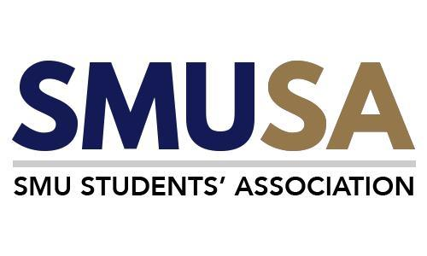

Singapore Management University

SMU Students’ Association

Financial Policies and Procedures Manual

22nd Students’ Association Council Finance Committee
5 April 2026

[This manual is intended for use by students]
Contents
1. Background 3
2. General Roles & Responsibilities 4
3. Policies & Forms 5
3.1. Budgeting (Annex A) 5
3.2. Statement of Accounts (Annex B) 7
3.3. Deposit of Funds 8
3.4. Purchasing (Annex E, E2, E3, E4) 9
3.5 Submission of Claims 13
3.7 Transportation 41
4. Documentation of Financial documents for student clubs 42
(W.E.F Jan 2020) 42
5. Auditing 42
5.1. FACT Audit 42
6. Clawback Policy 43
7. SMUSA Receipt Books 44
8. Budget Endorsement Meeting Standing Order 48
9. Appendix: List of School Clubs under C326 50

1. Background

The objective of this manual is to educate the Students’ Association Council (SAC), its constituent student bodies and clubs, and the general student population on the various financial procedures. With a variety of student clubs catering to diverse CCA in SMU, such clubs come under the administrative purview of school-based and non-school-based Constituent Bodies (CBds).

There are four CCA CBds, namely (1) ACF, (2) SICS, (3) SMUX, & (4) SSU, and seven school CBds, namely (1) ASoc, (2) Bondue, (3) The Bar, (4) SOSCIETY, (5) Oikos, (6) Ellipsis & (7) inCISive, looking after more than 100 student clubs in SMU.

The names and the contact details of your respective SA Exco and CBd Finance Secretaries (FINSECs) are listed below:

SA Exco

Honorary Finance Secretary: Lee Zhi Xuan (Email: finance@sa.smu.edu.sg)
Deputy Finance Secretary: Sng Swee Min / Stanley Choo (Email: a.finance@sa.smu.edu.sg)

School CBDs Finance Secretaries
ASoc
Celeste Chan Jing Ya (Email: celestechan.2024@accountancy.smu.edu.sg)
Bondue
Koh Rui Kai (Email: ruikai.koh.2025@business.smu.edu.sg)

Ellipsis
Khor Kyra (Email: kyra.khor.2024@scis.smu.edu.sg)
inCISive
Vasanth Mathiazhagan (Email: vasanth.m.2025@cis.smu.edu.sg)
OIKOS
Charlotte Lee Enqi (Email: enqi.lee.2024@economics.edu.sg)

SOSCIETY
Joel Tan Yan Yu (Email: joel.tan.2024@socsc.smu.edu.sg)
The Bar
Chia Rui Tian (Email: rt.chia.2024@law.smu.edu.sg)

CCA CBDs Finance Secretaries

ACF
Shannon Melody Singopranoto (Email: shannon.s.2025@accountancy.smu.edu.sg)

SICS
Lim Kang Ping (Email: kp.lim.2025@business.smu.edu.sg)

SMUX
Flora Tay Kai Xin (Email: flora.tay.2024@business.smu.edu.sg)

SSU
Lew Shi Qi (Email: shiqi.lew.2024@business.smu.edu.sg)

2. General Roles & Responsibilities

- Club FINSEC

    - Manage and account for the financial resources allocated to the club.

    - Comply with the Student Financial Procedures in carrying out the financial transactions of the club.

  - SA/CBd FINSEC

    - Consolidate and evaluate the overall CBd budgets before submission to Office of Student Life (OSL) through SAC.

    - Provide an oversight of the clubs’ financial matters to ensure compliance with the
Student Financial Procedures.

    - Manage and be accountable for the financial resources allocated to the SA/CBd.

    - To approve claims/expenditures for amounts less than SS$750.

  - OSL CBd Manager-In-Charge

    - Main point of contact to SA/CBd FINSEC in providing guidance and advice, to assist in ensuring clubs’ compliance with the SMU policies and procedures.

    - To approve claims/expenditures for amounts equal to or more than SS$750.

    - Consult, review and update the Student Financial Procedures with Office of Finance.

  - Office of Finance

    - Act as “banker” in processing and accounting all financial transactions from the student clubs.

    - Review and update the Student Financial Procedures with Office of Student Life from time to time.

3. Policies & Forms

3.1. Budgeting (Annex A)

Budgeting Term

SMUSA financial year is from 1st January to 31st December, and the budgeting period is split into two separate periods a year:

Term I : 1 Jan – 31 Jul (Mainly supported with the student activity fees that each student pays at the start of the new academic year)
Term II : 1 Aug – 31 Dec (Mainly supported with the student activity fees that each student pays at the start of the new academic year)

Budgeting Exercise

- All clubs/CBds are to prepare and submit their budget proposal, using Annex A, for review by the SA Finance Committee.

- All CBd Excos are to submit their budget proposals to the SA FINSEC, and the clubs submit their budget proposal to their CBD FINSEC who shall then submit the combined proposals to the SA FINSEC.

- All clubs/CBds are to plan their budget according to the Budget Guidelines.

- Constant reviews will be conducted by the SMUSA FINSECs and the CBD FINSECs to ensure that clubs/CBDs exercise prudence with regards to their budgets.

- The budgets of all the clubs/CBDs will be endorsed at the SA Finance Committee level before being approved by the SAC.

- The amount being budgeted for should only cover expenses for the respective terms (i.e. Budgeting for Term 1 must only encompass events happening in Term 1)

Budget Proposal - Annex A

- All forms that come together with Annex A must be filled up accordingly and must clearly indicate the amounts for the various activities planned. If there are other essential items (e.g. equipment etc.) that need to be purchased, please fill it up in accordance with the form.

- The CCA CBd Finance Secretaries are required to sign on the “Specimen Signature Record” electronically. This document serves as a security means to ensure that claims being made for the period stated.

- The “Term Budget Proposal Summary” document is to be filled up with the total funds requested for each activity. Breakdown for each activity should be provided in the various annexes, providing explanations for why each item listed is budgeted for.

- When listing down the breakdown of each event in the various annexes, a detailed explanation regarding the item in question is required to improve understanding of the necessity of the item budgeted.

- All forecasted income must be included in the Term Budget Proposal.

- Both President and FINSEC are responsible for achieving the clubs’ objectives within the approved budgets.

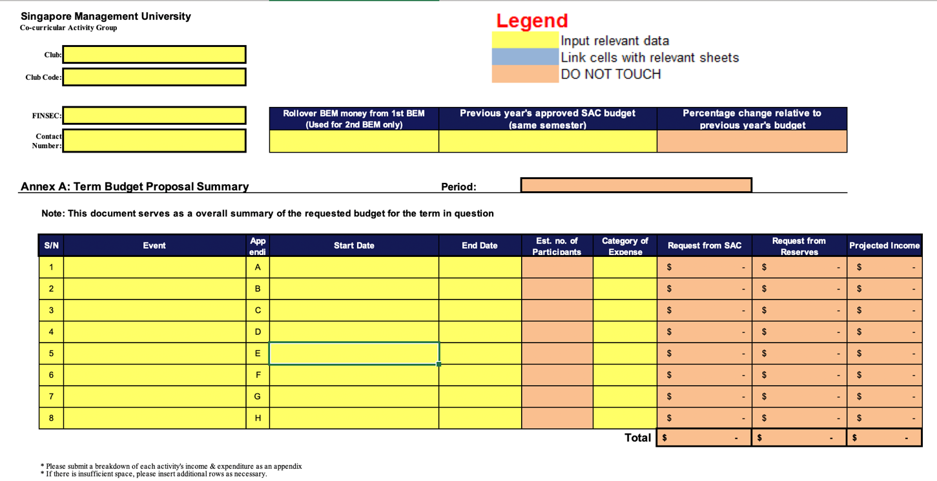

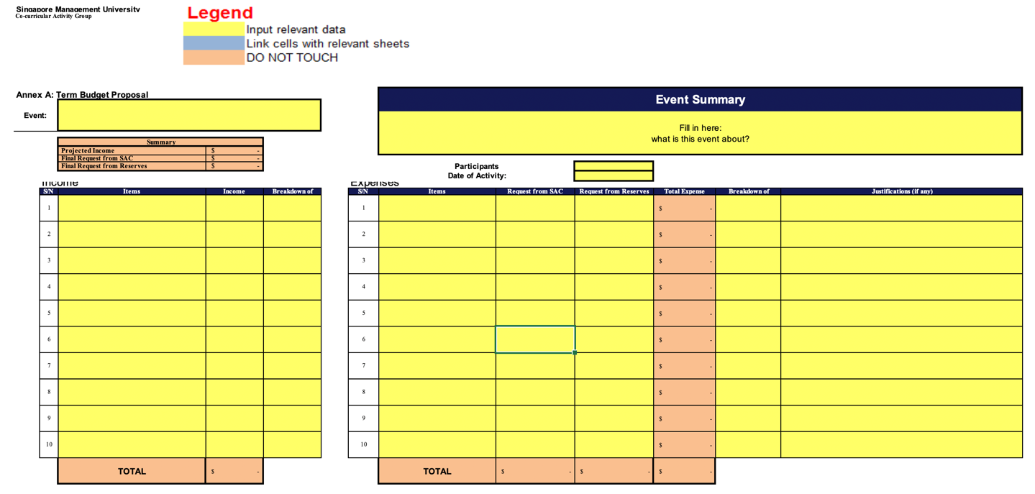

3.2. Statement of Accounts (Annex B)

Every club FINSEC is required to prepare and maintain a summary document of all income earned and expenses incurred for the period in question.

Benefits of maintaining Statement of Accounts (SOA):

- Provide a summary of income and expenses for the budget period.

- Serve as a supporting document when asking for sponsorships or financial support.

Roles

Club FINSECs:

- Prepare Club’s SOA and submit to CBd FINSEC.

CBd FINSECs:

- Reconcile Club’s SOA with SAP records and submit to SA FINSEC when requested.
- Prepare CBd Exco’s SOA and submit to SA FINSEC.

SA FINSECs:

- Compile total financial performance and report to OSL.

3.3. Deposit of Funds

All collections must be deposited with Office of Finance (OFIN) by 8pm on the same day of collection as per the SOP for Cashless Collection and Deposit.

All sponsorships and donations must have a letter indicating the benefits, if any, conferred upon the sponsor and donor.

Modes of Deposit

- Cheques
  - Cheques are to be made in favor of “SMU” or “Singapore Management University”
  - Indicate at the back of the cheque the name and club code of the intended recipient club/CBD.

- Cash (in accordance with OSL policy – to check with relevant CCA CBd fin sec/OSL staff)

- Bank Transfer (to refer to SOP for Cashless Collection and Deposit)

GST Deductions

- All Income/Sponsorships are subjected to GST deductions.

- Donations are not subjected to GST deductions.

- The final amount credited after GST deductions is calculated as follows:
Amount credited to club= Amount deposited *100/109

- Refer to the IRAS guidelines for more information regarding donations and sponsorships.

Donations

- All donations are to be addressed to OFIN

- Donation, through cheques, are to be made in favor of “SMU Term-Fund”. There is tax deduction for donor and there is not GST deductions

- Indicate at the back of the cheque the name of the intended recipient club/CBd.

Note: For the SA FINSEC, any deposit would have to be noted by the OSL CBd Manager In-Charge

3.4. Purchasing (Annex E, E2, E3, E4)

Small Value Purchase
- Single expenditure that is < S$1,000 (i.e. Buying numerous or single quantity of the same item whose total cost is less than SS$1,000).
- Purchases can be made off-the-shelf without the need to obtain quotations and raising of purchase orders (PO).
- Clubs/CBds are encouraged to obtain quotations so that the purchase being made is at the best (lowest available price).

Big Value Purchases – Quotations & Raising of POs
- For a single expenditure worth equal to or more than S$2,000, quotations must be invited.
- 1 quotation is sufficient, but Clubs/CBds are encouraged to obtain at least 3 quotations so that the purchase made is at the best (lowest available price).
- Written quotations can be obtained through the following ways:
- Email
- PDF of Invoice
- Exceptions of quotations:
- Pre-qualified vendors (refer to Pre-Qualified Vendors List in a separate document)
- Government-related fees (e.g. Licensing fees)
- For a single expenditure worth more than S$10,000, quotations must be invited as well.
- Minimum of 3 written quotations are to be called for
- Written quotations can be obtained through the following ways:
- Email
- PDF of Invoice
- Exceptions of quotations:
- Pre-qualified vendors (refer to Pre-Qualified Vendors List in a separate document)
- Government-related fees (e.g. Licensing fees)

For situations where a club/CBd is unable to come up with 3 quotations with valid reasons (e.g. only one vendor in Singapore, or venue booking contract insists that logistical/catering must be from designated vendor), the CCA/CBd FINSEC is to write a waiver of competition statement explaining the situation, and get the relevant authority’s signatory (as per SMU Approval Authority) to seek acknowledgement and approval. This letter is to be attached to the claim form when submitting claims.

For situations where a CBd/club is bounded by the contract, it would be better to obtain a supporting document from the external party to verify that the club/CBd is bounded by the terms of the contract.

- Raising of POs
- After quotations are obtained, the club/CBd HFS is required to send the quotation over to their relevant staff in charge and ask to raise a PO.
- A PO should be raised at least 14 working days before the scheduled delivery of goods.
- After the PO is successfully raised, the club/CBd HFS should obtain the invoice from the company (within 2 weeks from the date of PO) and send it to their relevant staff in charge for payment to be made. The invoice should be dated after the date of PO.
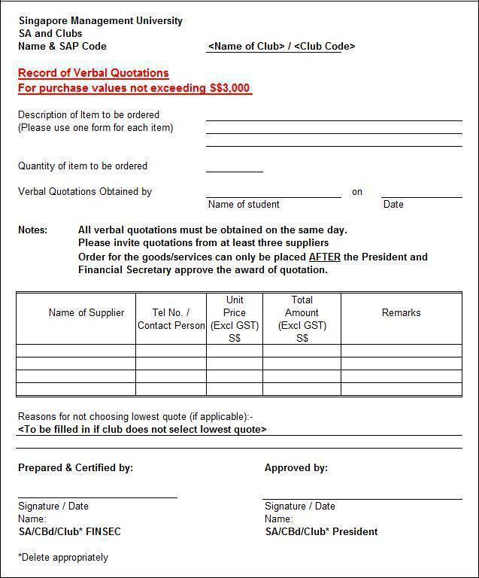

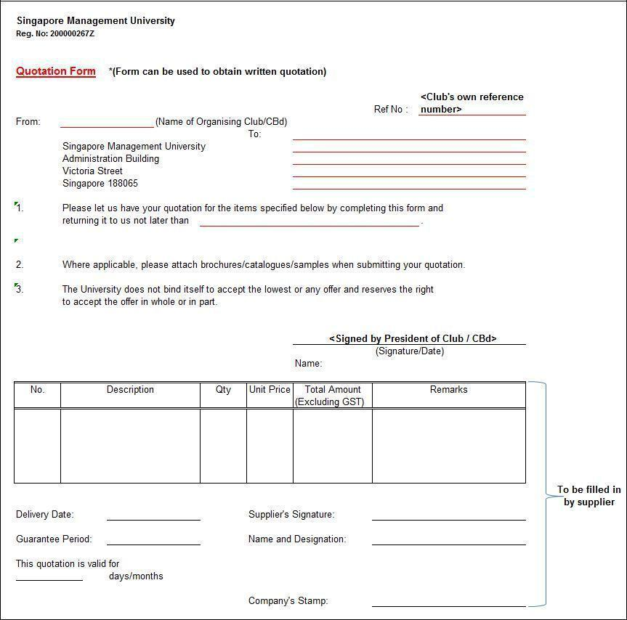

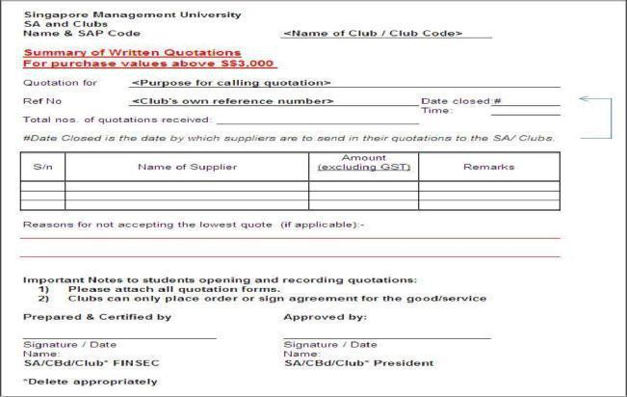

3.5 Submission of Claims
New E-Claim System, Launched 1 February 2024

For timely payment to suppliers / students, all invoices and purchase orders must be submitted for processing within 7 working days upon completion date of the project / event.

Below are the types of student claims to be processed via Student e-Claims System (SES):
• Events or Activities
• Event set-up and event related expenses (including meals / refreshments)
• Gifts for guests and visitors
• Local Transport - Private Hire, Taxi, Bus, Train
• Name Cards, Name Badge
• Overseas Travel related expense
• Printing of posters, reports / newsletters
• Prize - Lucky Draw, Competitions, Survey
• Postage, Delivery Costs
• Rental of Facilities for activities
• Repairs & Maintenance of Motor Vehicles, Bikes, Boats
• Research Participants Costs
• Stationery
• Software License or monthly/Annual subscriptions
• Training / Workshop / Conference Fees
• Uniform or Clothes for performance, games and event participation

Claims unable to be processed via SES:
• Payments to Coaches / Vendors
• Awards / Bursaries / Prizes to students

Student Process Claim in Summary
Step | Action Party | Action
1 | Claimant | a. Raise an online claim form via SES along with supporting attachments  b. Enter email of Verifier 1  c. Save and Submit claim form online
2 | Verifier 1 | Verify Claim and enter email of Verifier 2 or 3 (if any) and Authorised Approver
3 | Verifier 2 | If any, to verify claim
4 | Verifier 3 | If any, to verify claim
5 | Authorised Approver | Approve Claim for Processing
6 | Finance | Process Claim
7 | Claimant | Receive Payment from Bank

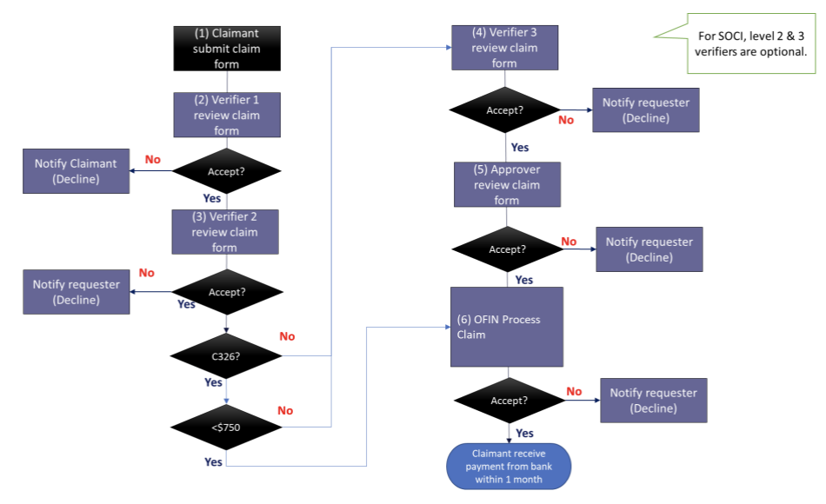
Claimant Process
To submit a claim, please go to the Student e-Claims System (SES).

Claimant Home Screen
It is important to read the notes on supporting documents. Incorrect or insufficient supporting documents submitted may lead to delays in reimbursement of expenses.

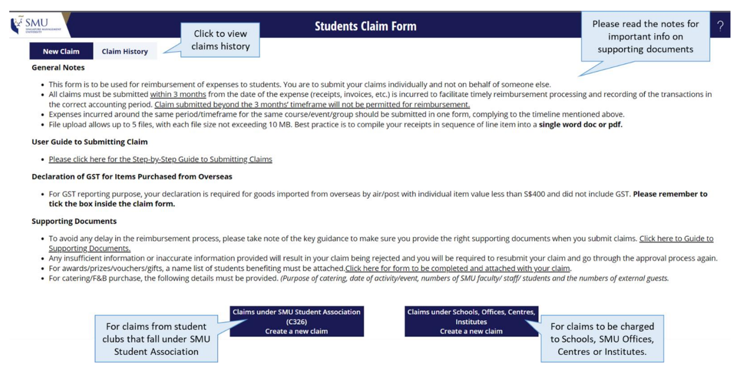
Create a claim under SMU Student Association C326

Step 1: Click on the option “Claims under SMU Student Association (C326) Create a new claim”

Once you click on the claim page, you will see a page with explanatory notes pertaining to claims for student clubs.

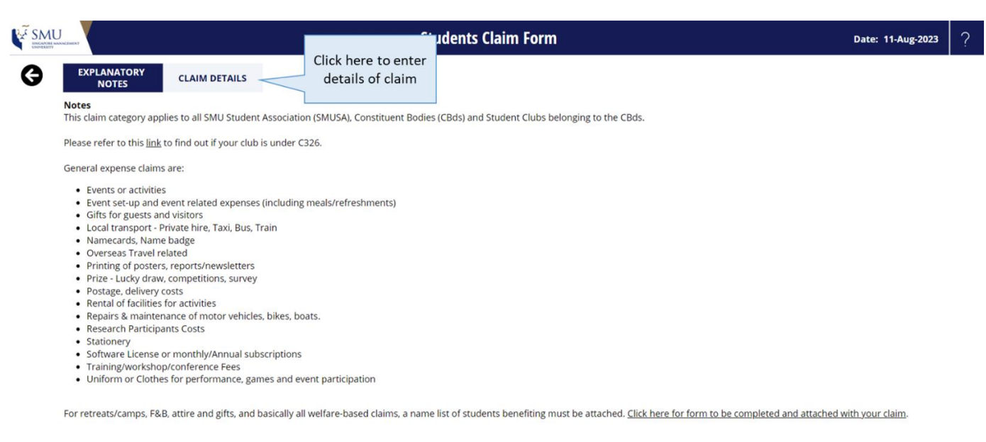
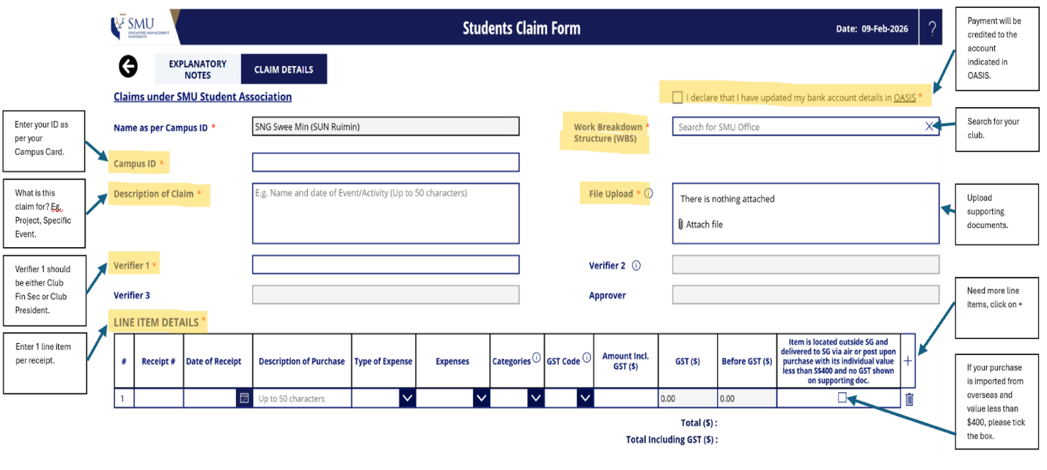
Step 2: Enter the claim details in the form. All mandatory fields must be completed in order to submit the claim.
Step 3: Submit claim form to Verifier 1 by clicking “Submit” at the bottom of the page.
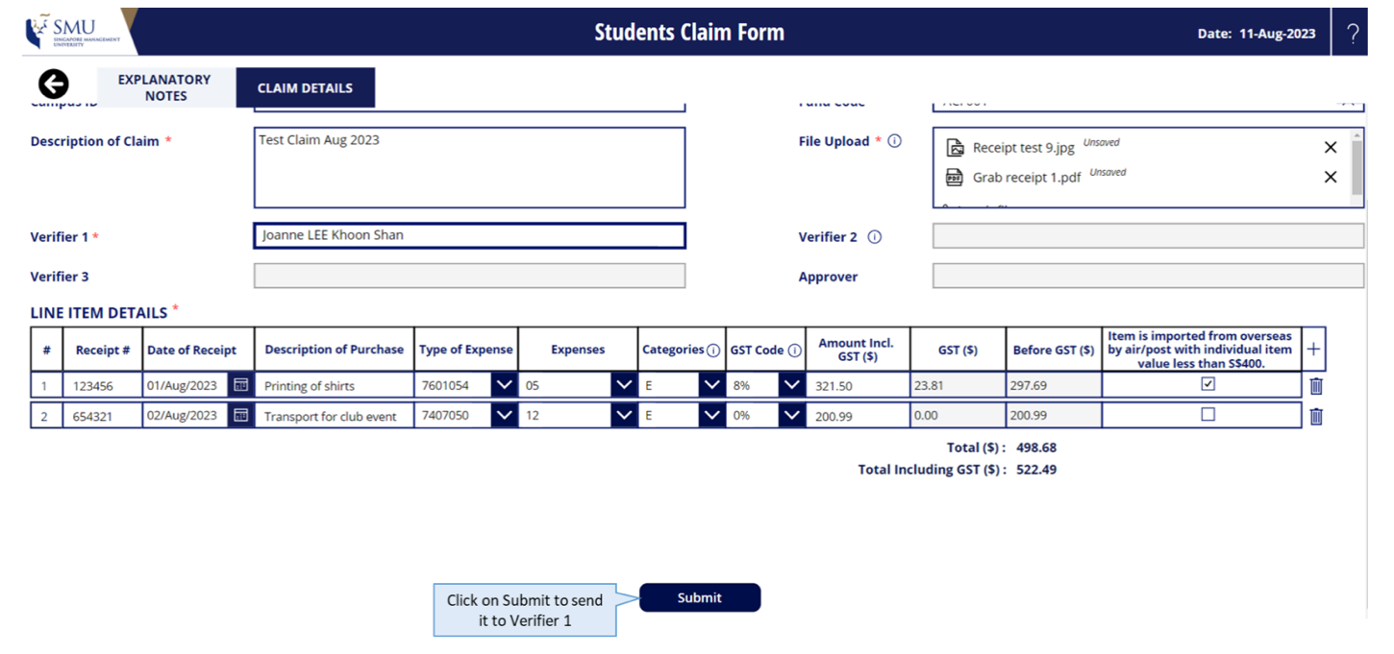

Step 4: After clicking “Submit”, there will be a page indicating that the claim has been submitted successfully.
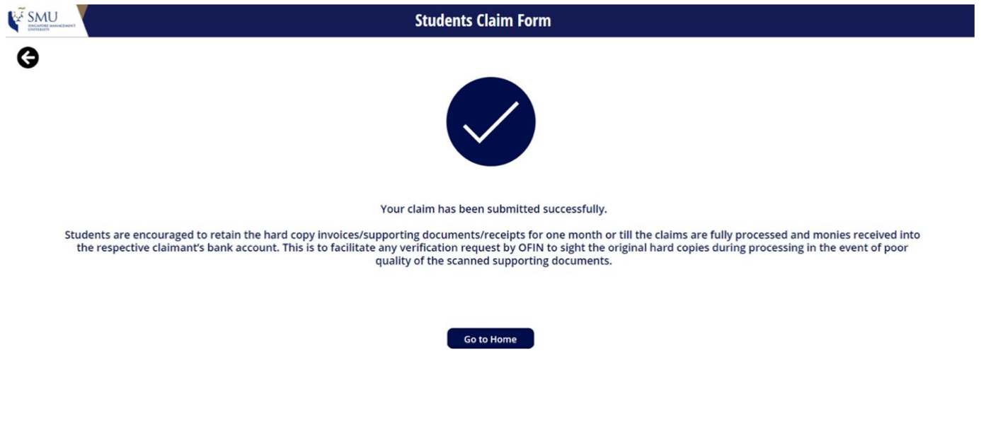
Step 5: Upon completion, you will receive an email notification to inform you have submitted a claim.

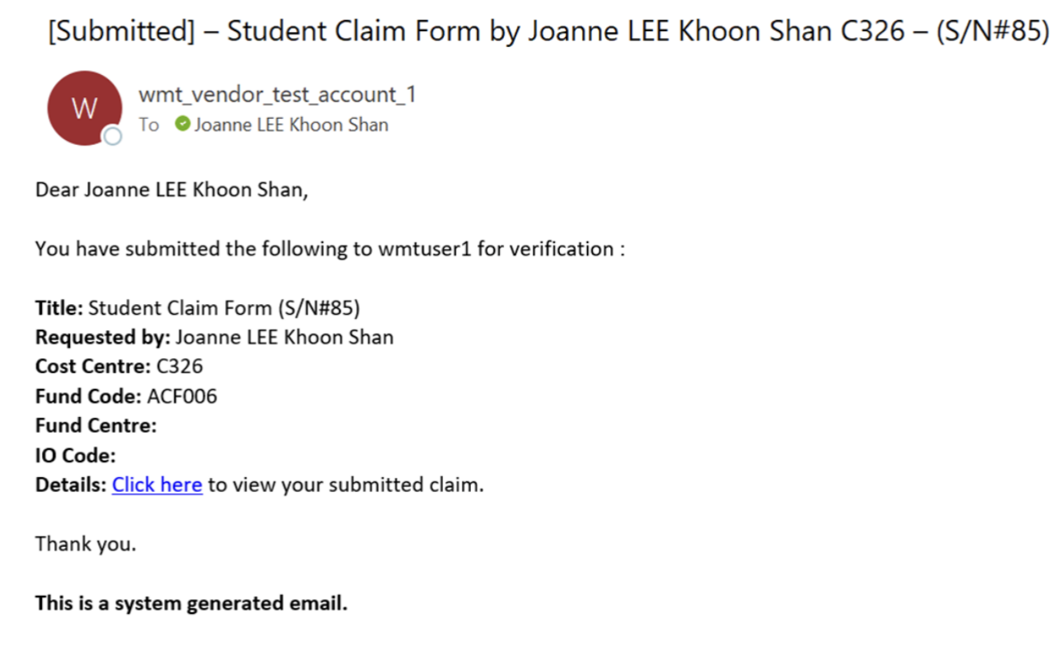
Subsequently, you will receive status update emails at each stage of verification and approval, giving you visibility of where your claim is at.

Re-submit a rejected claim
Step 1: You will receive an email notification if your claim has been declined. To re-submit the claim,
please click on the link under “Details”.

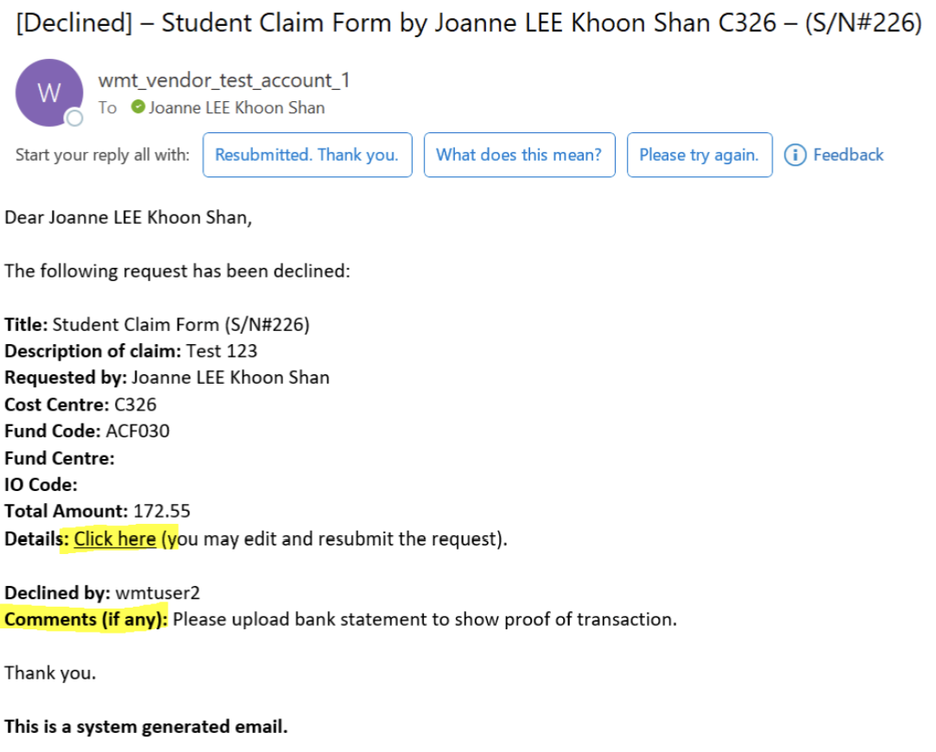
Step 2: Once you have edited your claim form, please make sure to click “Save”. Your claim will go
through the verification and approval process.

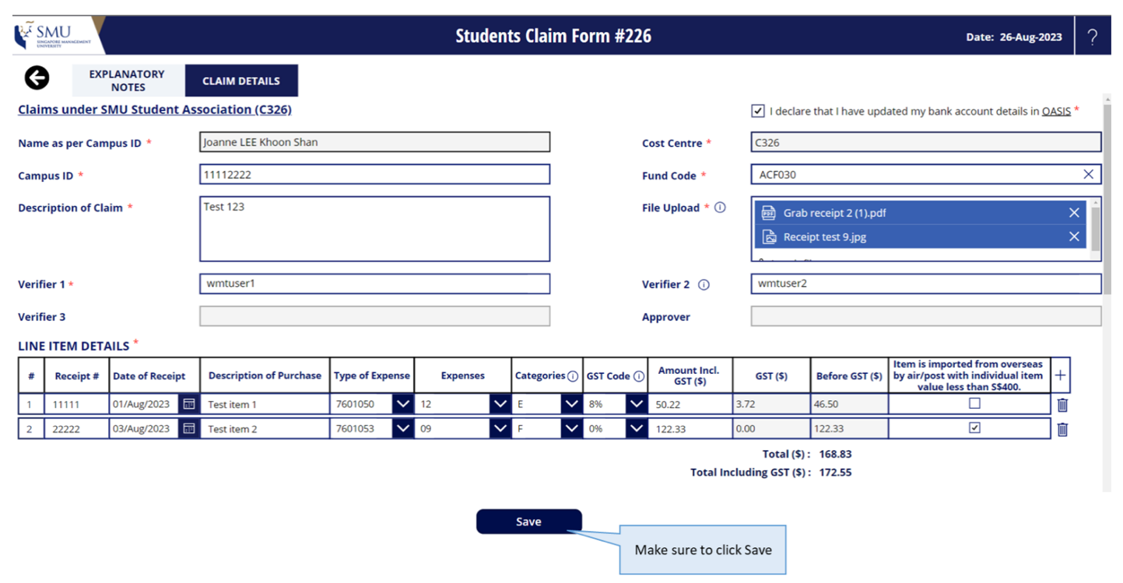

View Claims History
View from Claims Home Page

To view all historical claims raised, click on the “Claim history” tab on the Home Page.
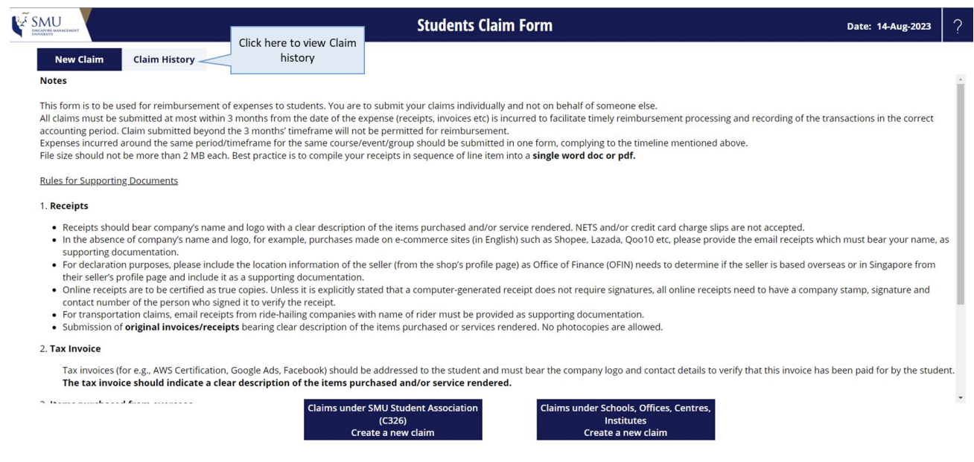You will see a list of Claims that you have previously submitted. Click on the claim number to view the
claim form.

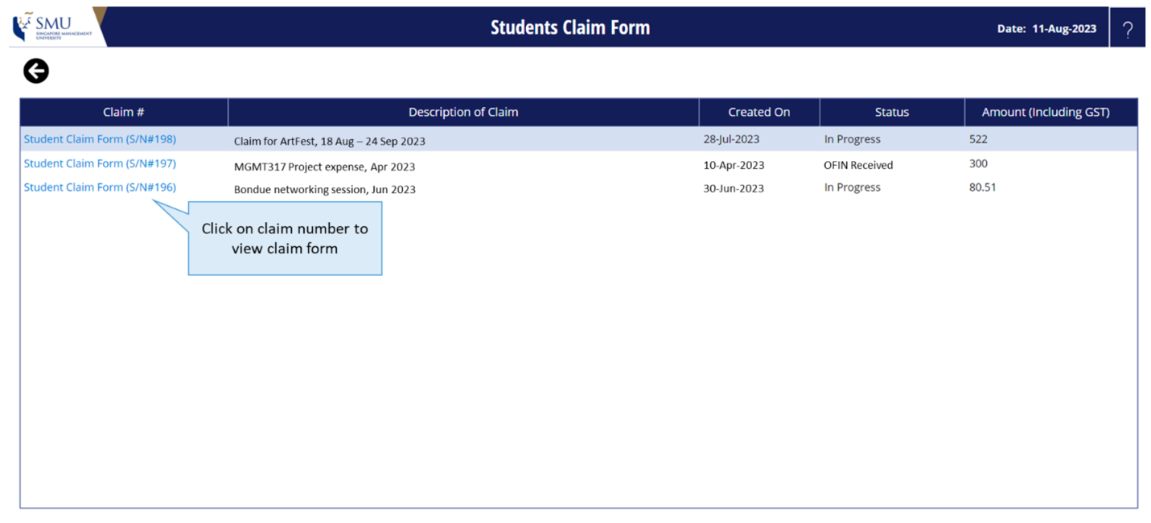
View Verification and Approval History

You will be able to view the Verification and Approval History via your claim form. After you have
clicked on the form in the Claim History page, you will be brought to your claim form. Approval History
is located at the end of your submitted claim form.

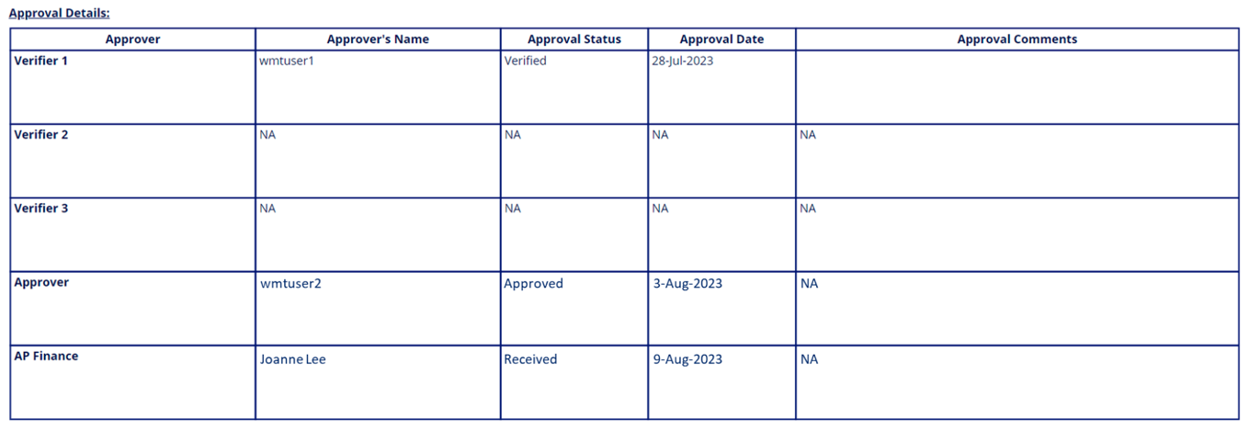

Verification and Approval Process

Verification Process for SMU Student Association (C326) for amount <$750

Verifiers will receive email notification when there are claims to verify. Verifiers can click on the link in
the email to access the claim.

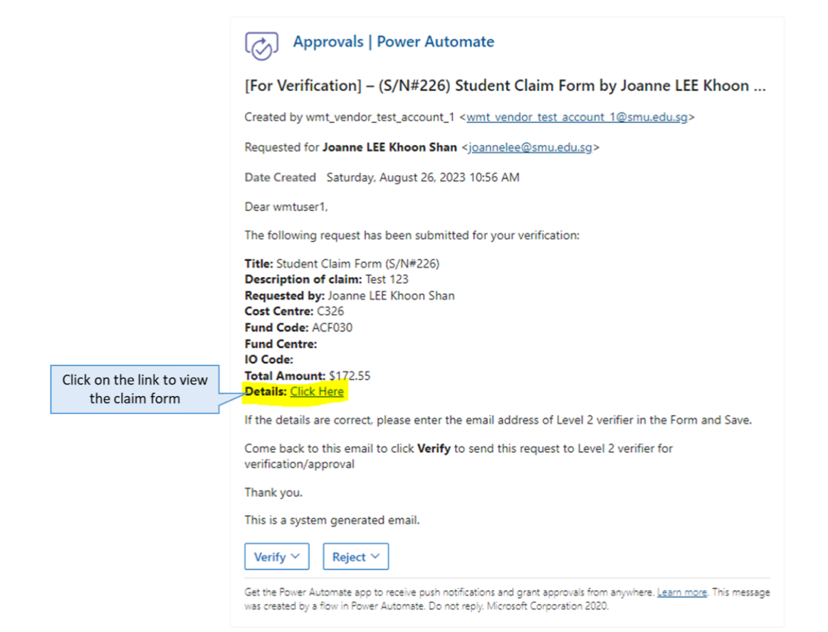

Verifier 1
Step 1: Once you have received the email notification, please review claim form. Verifiers are able to
edit the claim form.
Step 2: Verifier 1 must enter an email in Verifier 2 for the form to proceed to the next person. For
claims under C326, Verifier 2 is SMUSA HFS or CBD HFS.
Step 3: Make sure to click Save.

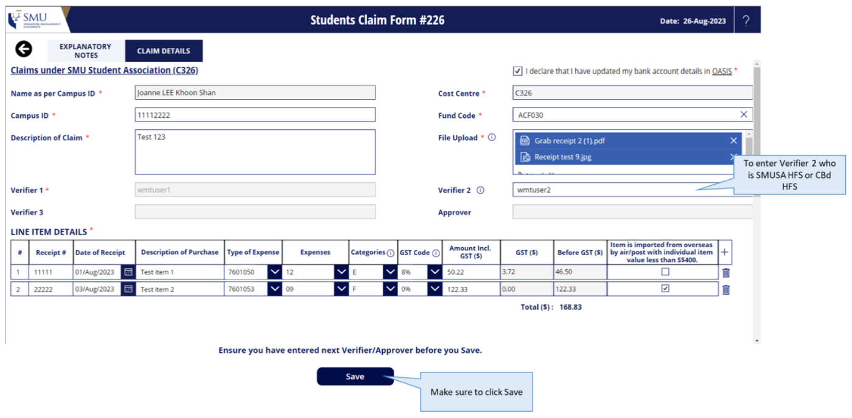

Step 4: After you have saved the form, please go back to your email notification to Verify or Reject the
claim.
If you click on Verify, the claim will be routed to Level 2 for Approval.
If you click on Reject, the claim will be routed back to Claimant. Please enter comments to inform
Claimant the reason for rejection.

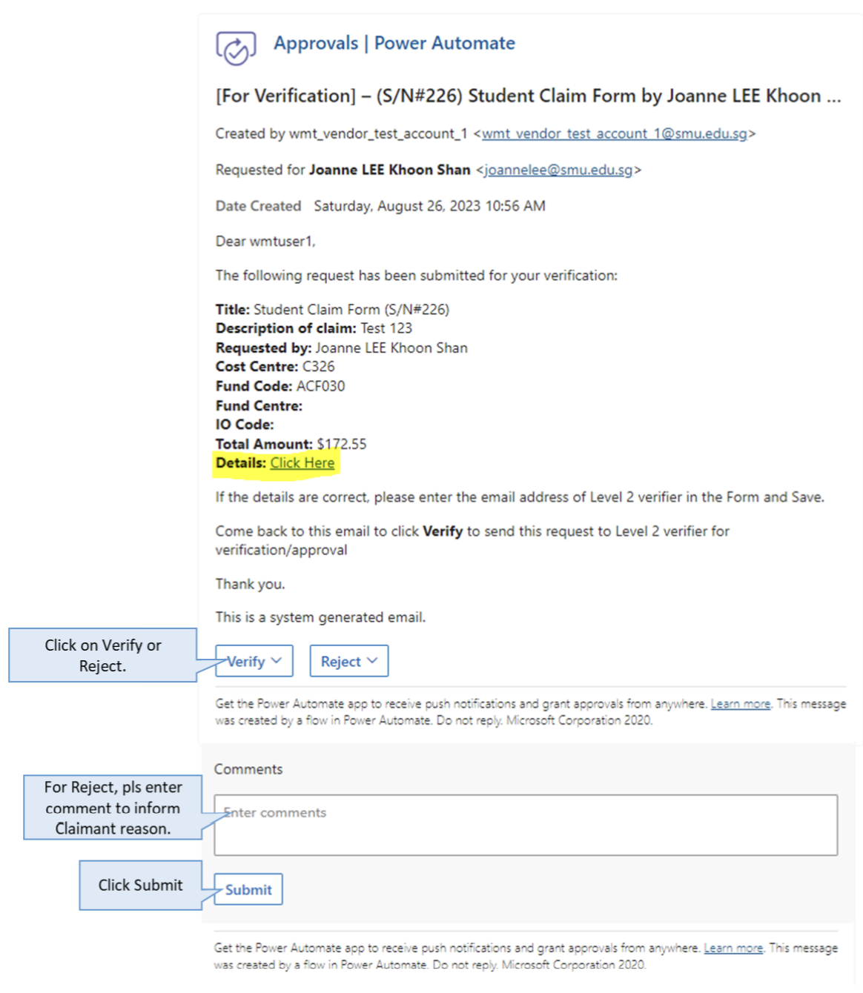

Approval Process for SMU Student Association (C326) for amount <$750
Approver
Step 1: Once you have received the email notification, please review the claim form. Approvers are able to edit the claim form.
Approver should be either SMUSA HFS or CBd HFS. If claim amount is <750, Verifier 3 or Approver is not needed.
Step 2: If any edits have been made to the form, make sure to click Save
Step 3: After saving the form, please go back to your email notification to Approve or Reject the claim
If you click on Approve, the claim will be routed to Office of Finance.
If you click on Reject, the claim will be routed back to the Claimant. Please enter comments to inform the Claimant the reason for rejection.
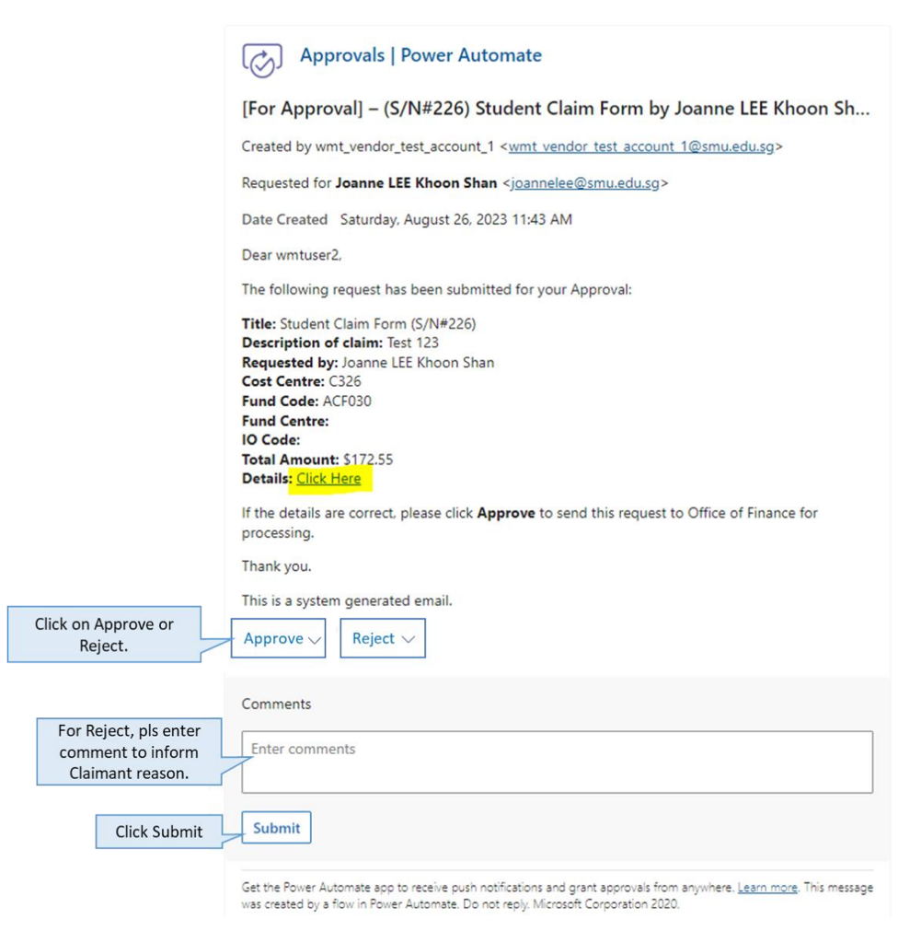

Verification Process for SMU Student Association (C326) for amount >$750
Verifier 1
Step 1: Once you have received the email notification, please review claim form. Verifiers are able to edit the claim form.
Step 2: Verifier 1 must enter an email in Verifier 2 for the form to proceed to the next person. For claims under C326, Verifier 2 is SMUSA HFS or CBD HFS.
Step 3: Make sure to click Save.

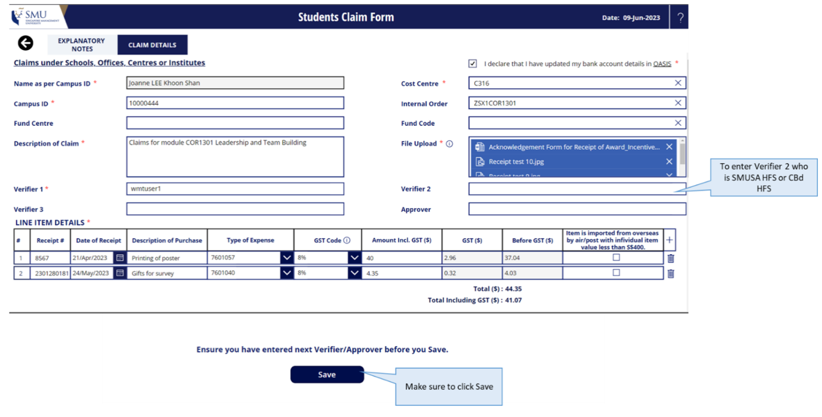
Step 4: After you have saved the form, please go back to your email notification to Verify or Reject the claim. If you click on Verify, the claim will be routed to Level 2. If you click on Reject, the claim will be routed back to Claimant. Please enter comments to inform Claimant the reason for rejection.
Verifier 2
Step 1: Once you have received the email notification, please review the claim form. Verifiers are able to edit the claim form. Verifier 2 should be SMUSA HFS or CBD HFS.
Step 2: For claim amount more than $750, you will need to indicate Verifier 3 who is your Club Manager.
Step 3: Make sure to click Save.
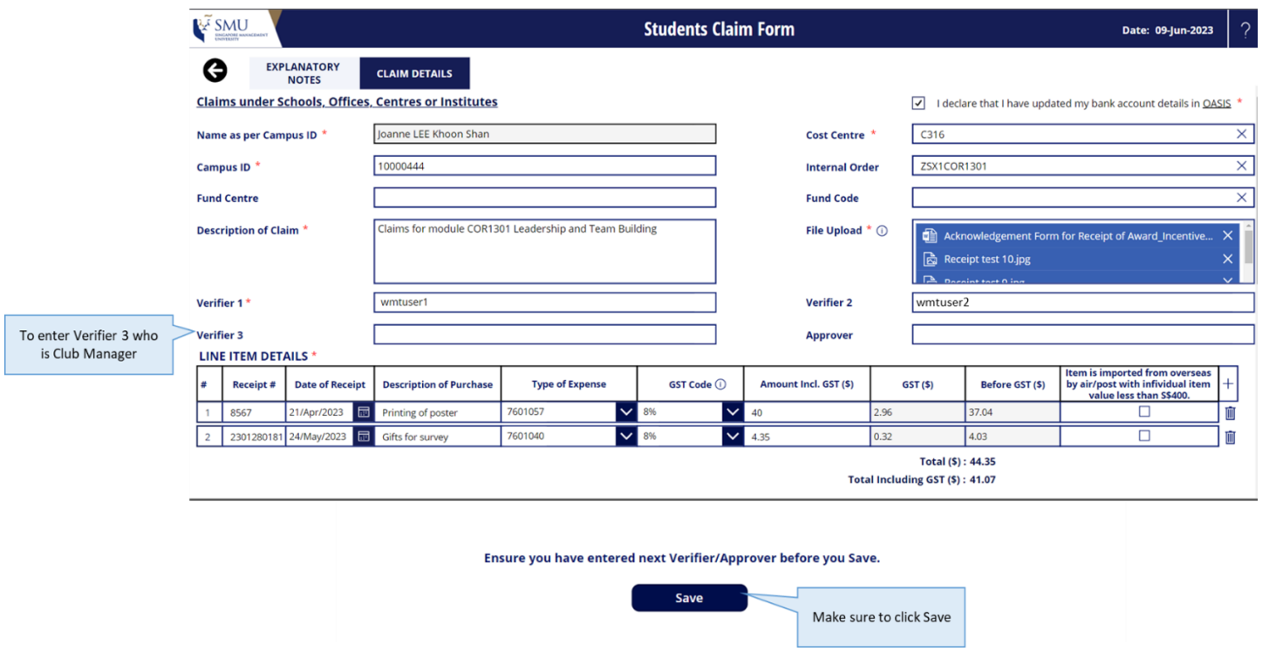
Step 4: After you have saved the form, please go back to your email notification to Verify or Reject the claim. If you click on Verify, the claim will be routed to Verifier 3. If you click on Reject, the claim will be routed back to Claimant. Please enter comments to inform Claimant the reason for rejection.

Verifier 3
Step 1: Once you have received the email notification, please review claim form. Verifiers are able to edit the claim form. Verifier 3 should be the Club Manager.

Step 2: For claim amount more than $750, you will need to indicate Approver who is your Cost Centre’s Approving Authority as per the Corporate Authorization Policy.

Step 3: Make sure to click Save.
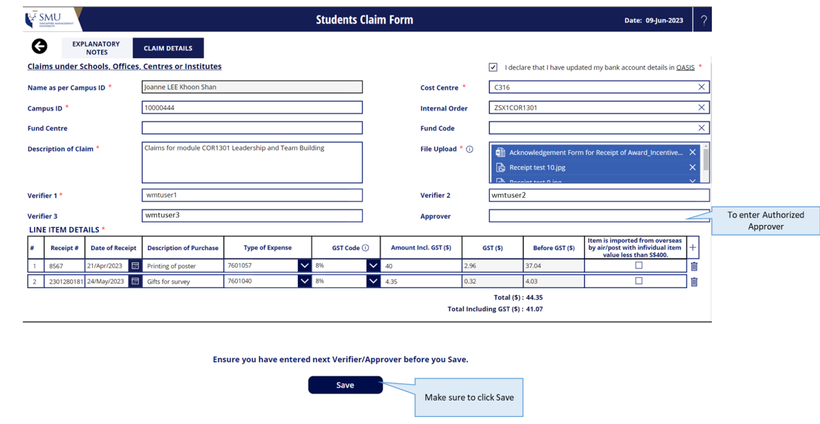
Step 4: After you have saved the form, please go back to your email notification to Verify or Reject the claim.
If you click on Verify, the claim will be routed to Approver.
If you click on Reject, the claim will be routed back to Claimant. Please enter comments to inform Claimant the reason for rejection.
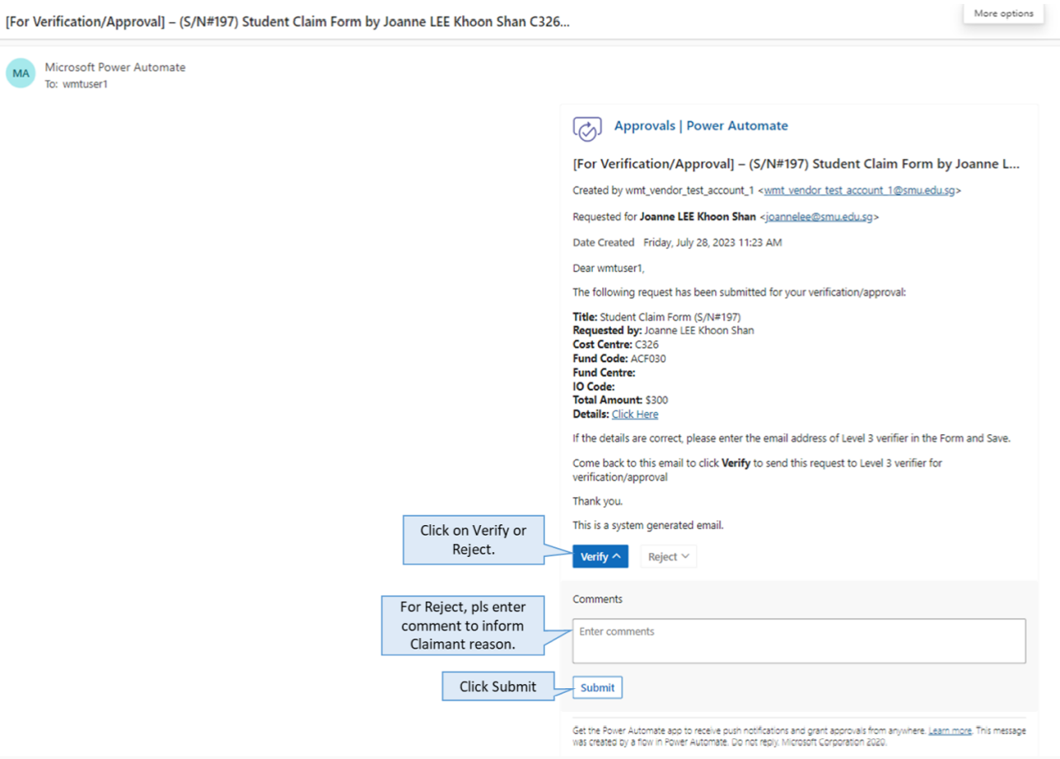

Approval Process for SMU Student Association (C326) for amount >$750

Approver
Step 1: Approver should be Approving Authority as per the Corporate Authorization Policy. Once you
have received the email notification, the supporting attachments and copy of the claim form
Submitted.
If you click on Approve, the claim will be routed to Office of Finance.
If you click on Reject, the claim will be routed back to Claimant. Please enter comments to inform
Claimant the reason for rejection.
Step 2: If you would like to make edits to the form, please click the link under Details, you will be
brought to the browser where the form will load.
Step 3: After you have made edits to the claim form, make sure to click Save.
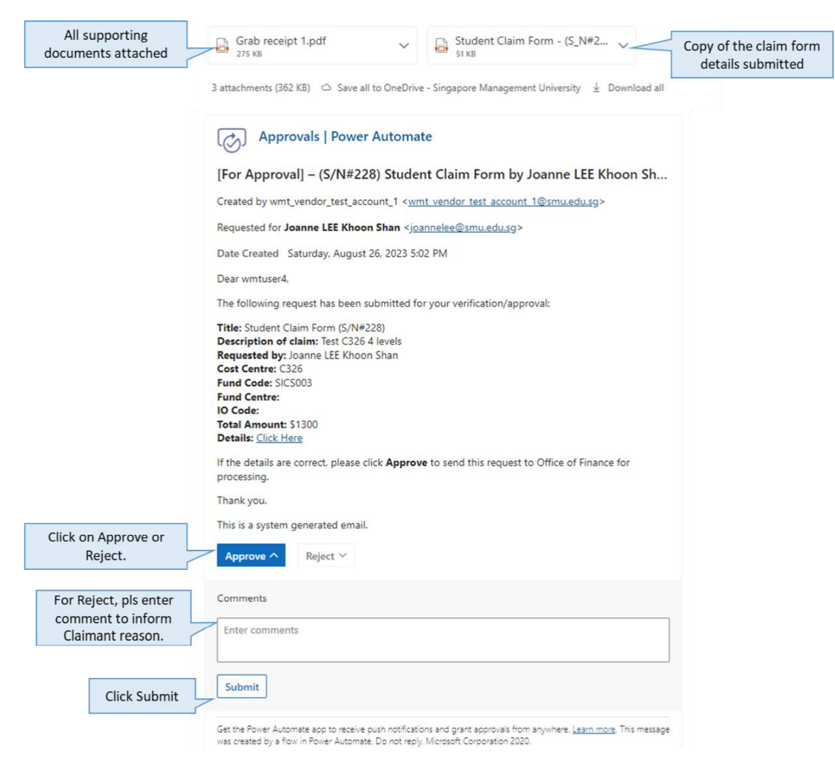

Alternative methods to view claims received, verified and approved.
There are alternative ways where you will be able to view claims that you have received, verified
and/or approved.

Via Microsoft Teams

a. On the left panel of your MS Teams, click on the 3 dots, and select Approvals
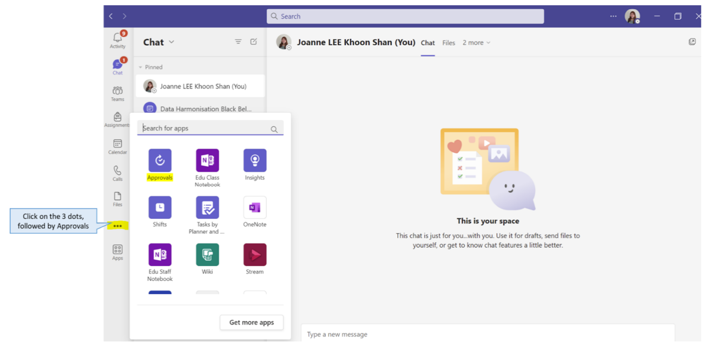

b. You will see a list of items that you have received as a Verifier or Approver. Click on the item to
view the details.

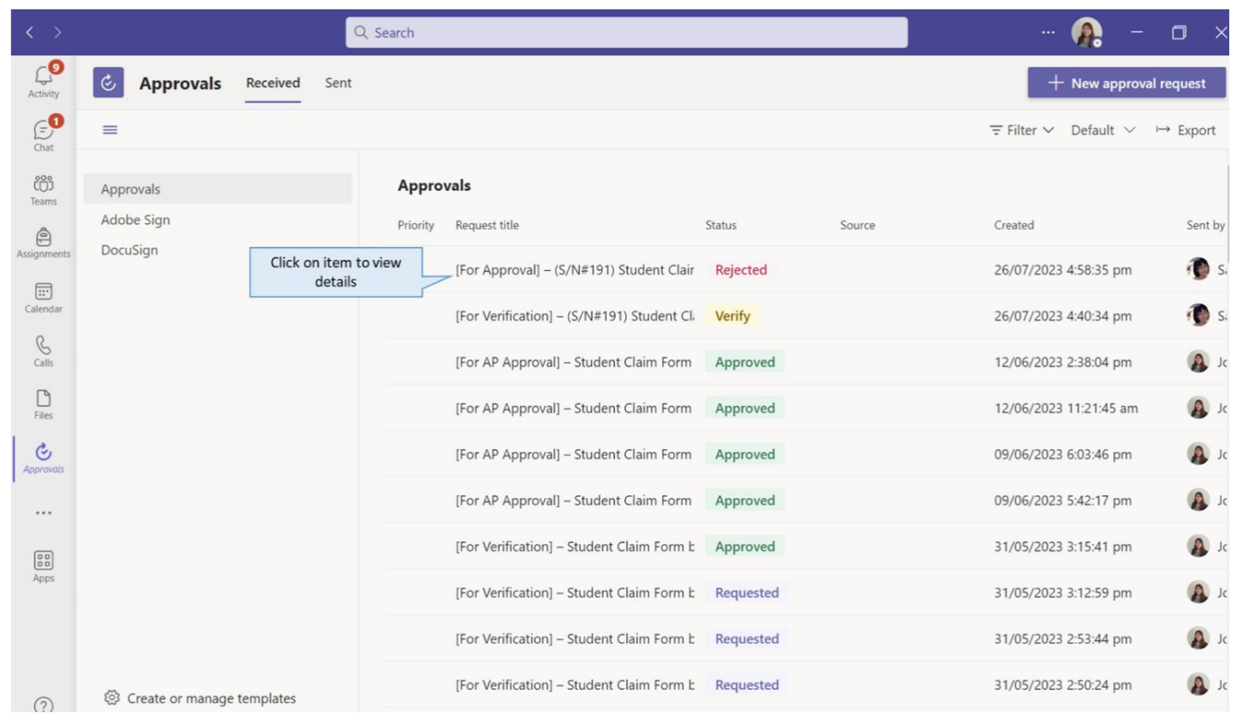

c. Once you click on the item, a pop-up window will appear with the claim information. You can click
on the link to view the form. You will also be able to take an action to Reject or Approve the claim
if you have not done so.

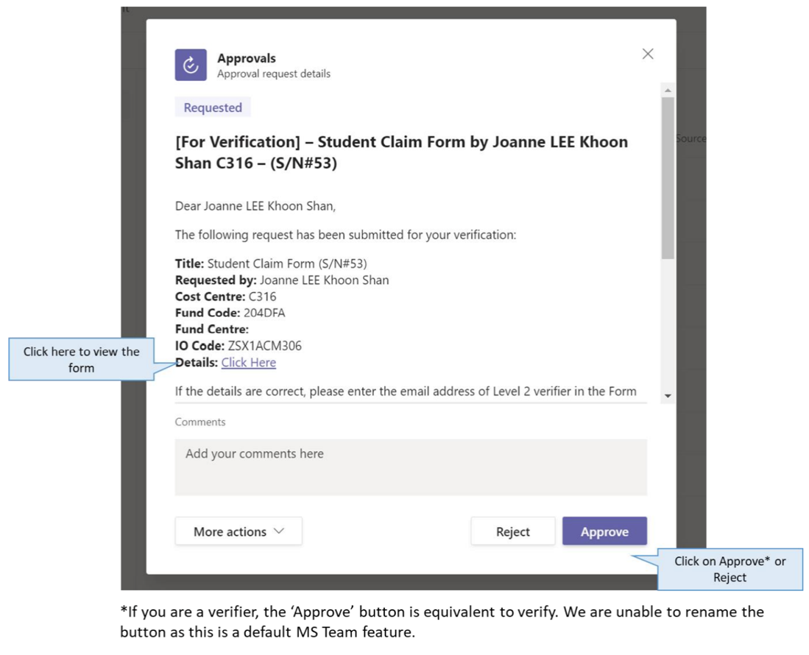

Via Microsoft Power Automate on web browser

- You may go to the Microsoft Power Automate Website: https://powerautomate.microsoft.com/en-sg/

- Log in with your SMU Credentials, ie: SMU Email Address and Password.

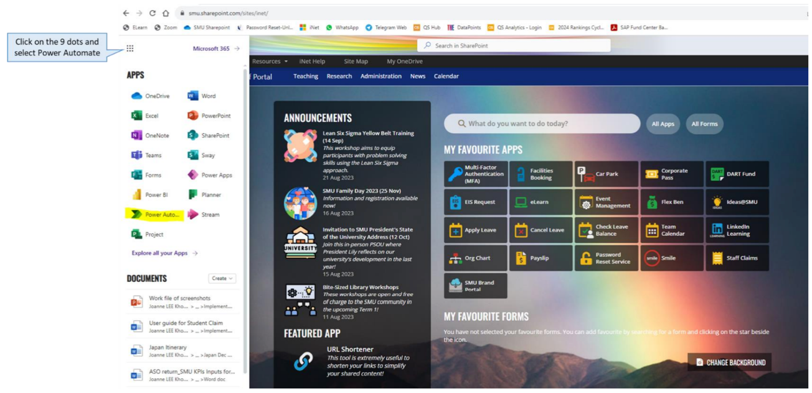

- In the Power Automate page, click on Approvals and you will see a list of items that you have received as a Verifier or Approver. Click on the item to view the details.

- Click on the item to view details.

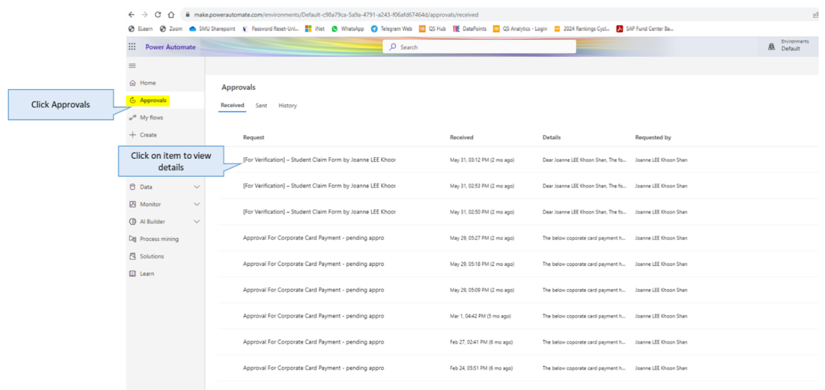

- Once you click on an item, the left panel will show details of the claim. You can click on the link to view the form. You will also be able to take an action to Reject or Approve the claim if you have not done so.

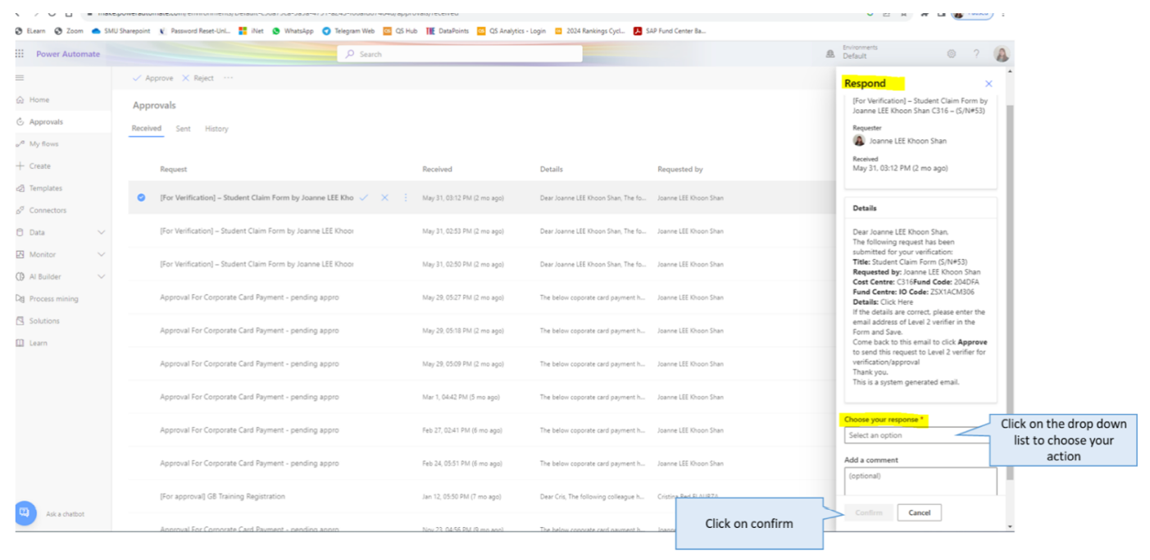

View History Via Microsoft Power Automate on web browser

- You may go to the Microsoft Power Automate Website: https://powerautomate.microsoft.com/en-sg/

- Log in with your SMU Credentials, ie: SMU Email Address and Password.

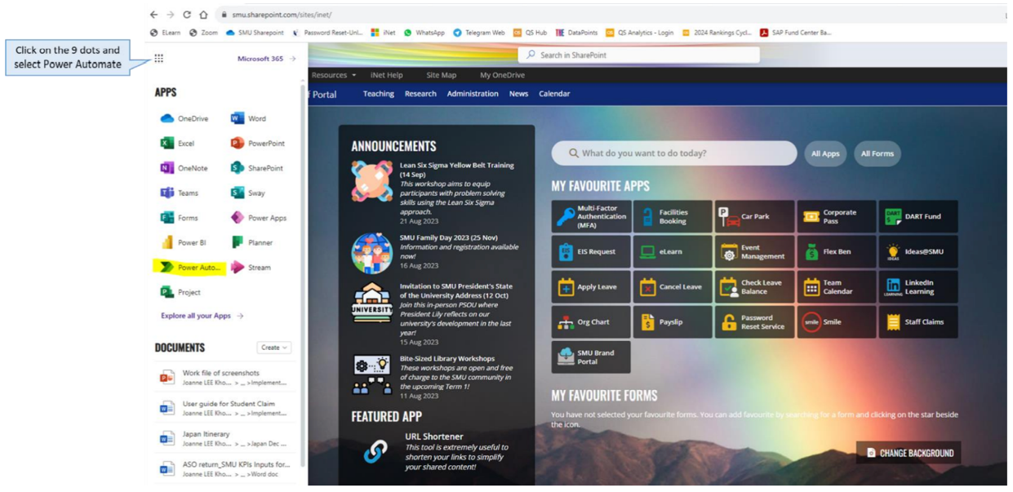

a. In the Power Automate page, click on History and you will see a list of items that you have previously verified or approved. Click on the item to view the details.

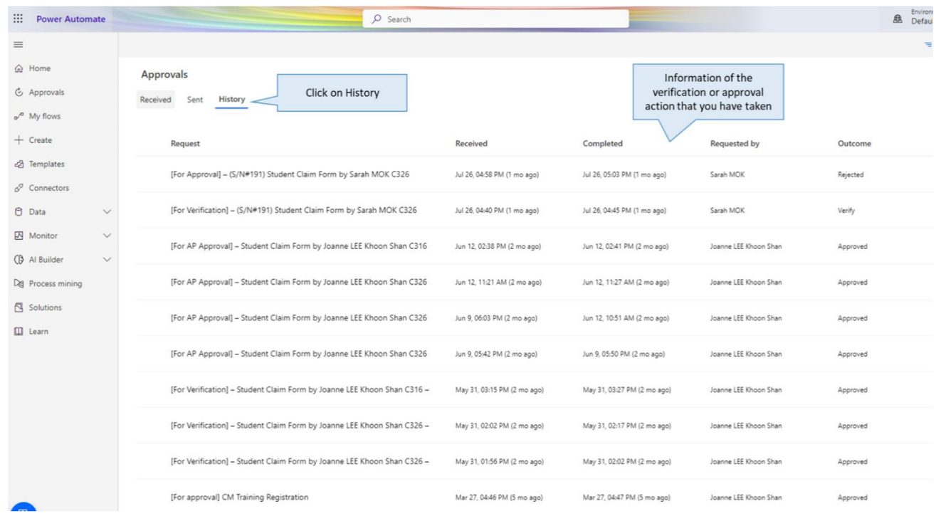

Reimbursement Timeframe

As a general rule, a claim shall be reimbursed between 30 to 45 days from date of submission of claim by a member, assuming each approving authority takes not more than 7 working days to process the claim and the claim submitted is complete and correct:

- Claim from Club’s FINSEC to CBd FINSEC – by 7th working day from receipt from claimant

- From CBd FINSEC to OSL – by 7th working day from receipt (if the claim amount is below $750, there is no need to go through OSL)

- From OSL to Office of Finance – by 7th working day from receipt

- Process payment and inform claimant of payment – by 7th working day from receipt. As long as the timeline and requirements of the claims process is adhered to or even better, the process is speeded up by the prompt submission at every level; students would be able to receive their claims in a possibly shorter period of time.

Payment to Vendor (Local)

- Students who purchase products from suppliers should ask for a 30-Day credit term (inform the vendor that they should receive their payment within 30 Days, provided the claims are submitted promptly and according to the timeline of payment given above)

- Only tax invoices are accepted as supporting documents for payment to vendors. No delivery orders, pro forma forms, quotations are accepted as supporting documents.

- All invoices should be billed to the address below but collected by the club/CBD and submitted together with the Payments/Claim Form (Annex F):

Singapore Management University

Administration Building

81 Victoria Street

Singapore 188065

Attention to: Payee Name (CCA/Organization)

Reimbursement to Student

- Tax invoices and Receipts are accepted as supporting documents for payment to students. However, there are more things to take note of in a tax invoice.

- If in a situation where a company issues an invoice and the student has paid for the purchase,

  - the student’s name must be explicitly stated on the invoice and (b) company stamp, signature and contact number of the person who signed it must be explicitly shown on the invoice to verify that this invoice has been paid for.

- Refer to below for the rules with regards to submission of supporting documents for payment to students

Approving Authorities for Claims

Payment / Claim Amount Approving Authorities (per invoice / claim)
- Up to S$750 SA / CCA CBd / School CBd FINSEC*
- S$750 and above as per SMU Approval Authority
* Individual claims by any FINSEC shall be approved by a higher authority.

Rules for Supporting Documents/Claim Form (Annex F)

All claimants, certifying and approving officers must ensure the following:

- Submission of original invoices/receipts bearing clear description of the items purchased or services rendered. No photocopies are allowed.

- Online receipts are to be certified as true copies. Unless it is explicitly stated that a computer-generated receipt does not require signatures, all online receipts need to have a company stamp, signature and contact number of the person who signed it to verify the receipt.

- “NETS" receipts & credit card charge slips are NOT accepted.

- Receipts are required to have companies’ logo and/or name unless justifiable.

- Declaration is required for goods imported from overseas by air/post with individual item value less than S$400.

- For cases of payee name on the claim form being different from the names on the invoice/receipt. Get the person whose name is on the invoice/receipt to write a letter acknowledging that the person whose name is on the claim form has paid on his/her behalf through the following template (Form D – Letter of Authorization):

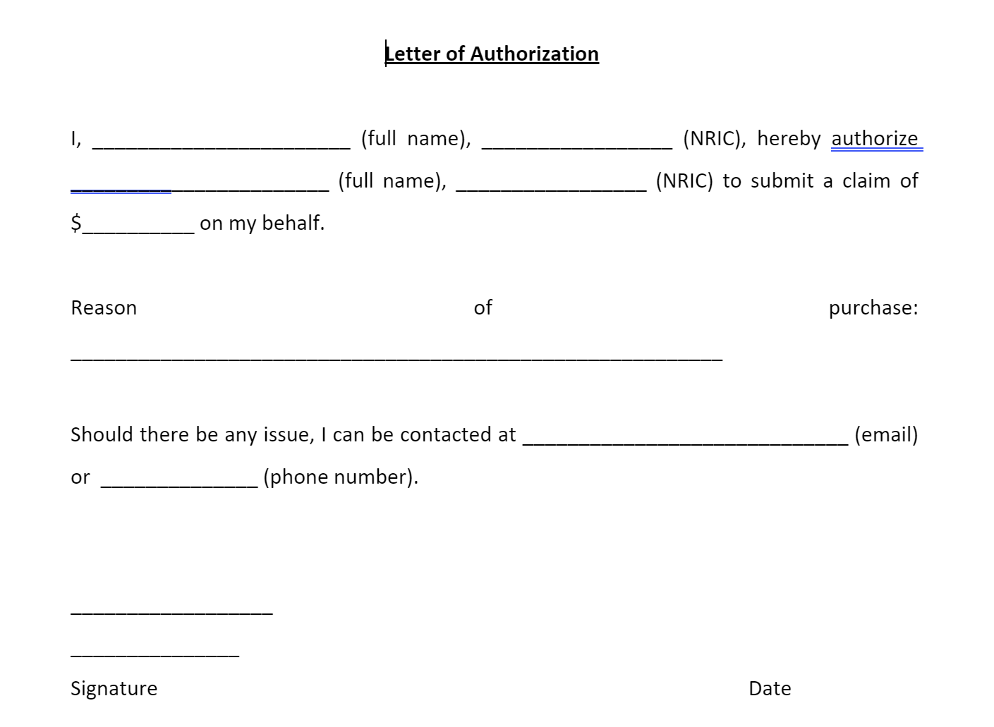

Singapore Management University SMU Students’ Association Financial Policies and Procedures Manual

- Full name of the payee name must be written in Annex F

- For retreats/camps, F&B, attire and gifts, and basically all welfare-based claims, a name list of students benefiting must be attached.

- Claims by the same individual, for the same event / group of events at the same time or near each other should be put into 1 form.

- President cannot be the Certifying officer of claims if he is claiming; Vice-President to be Certifying officer instead. Similarly, if the Finance Secretary is claiming, OSL CBd Manager shall be the Approving officer.

- Vice-President can only authorize claims if and only if (1) President is unavailable for an extended period of time and (2) the claim is of urgent need to be processed such that it will be too late to wait for President to become available.

- For Items purchased overseas and in foreign currencies, please convert the purchase using the following currency converter website: http://www.oanda.com/convert/classic . Print out the conversion calculation and attach it to the payments/claim form (Annex F). Please also indicate on the claim form, the date the conversion was calculated.

- For cases of Freelance Service Providers who do not have their own invoices or for vendors who do not issue receipts (E.g. Freelance Photographers hired for photo shoots), get the vendor to write a letter (signed by the Vendor) to acknowledge receipt of cash comprising of the following (Form E - Unofficial Confirmation Receipt):


I, ______________________________, __________________, hereby declare that I received

(Name) (NRIC)

$___________ from ___________________________________, _______________________,

(Amount) (Name) (NRIC)

for the services I have rendered to _________________________________________________

(Club/Committee)

for the _______________________________________________ on _____________________.
(Event) (Date)

The service(s) which I have rendered were:
__________________________________________________________________________________
__________________________________________________________________________________
__________________________________________________________________________________

__________________________________________________________________________________
__________________________________________________________________________________

Signature: ____________________________ Signature: ____________________________

Name: _______________________________ Name: _______________________________
NRIC: ________________________________ NRIC: ________________________________
Contact Number: _______________________ Contact Number: ______________________
Date: _________________________________ Date: ________________________________

§ When cheques are issued, please note that the validity is 6 months and that OFIN will not entertain any request to reissue a cheque if the cheque is deposited after the validity period.

Overseas Suppliers

The following additional information is needed for payment to overseas suppliers:

- Original copy of the invoice. If e-invoice, must indicate that “This is a computer-generated invoice, no signature is required”.

- Confirmed that the goods have been received or services have been done. (E.g. Delivery Order)

- Bank Account details like:

  - Account Name

  - Bank Name

  - Bank Address

  - Account Number

  - Swift Code/BIC (example of swift code for HSBC Bank in Hong Kong
should look like this: HSBCHKHH)

- Quotations

- Copy of Email Communication between the two parties

- For any monetary transactions, credit card slips/bank account transfer slips must be provided.

Annex F
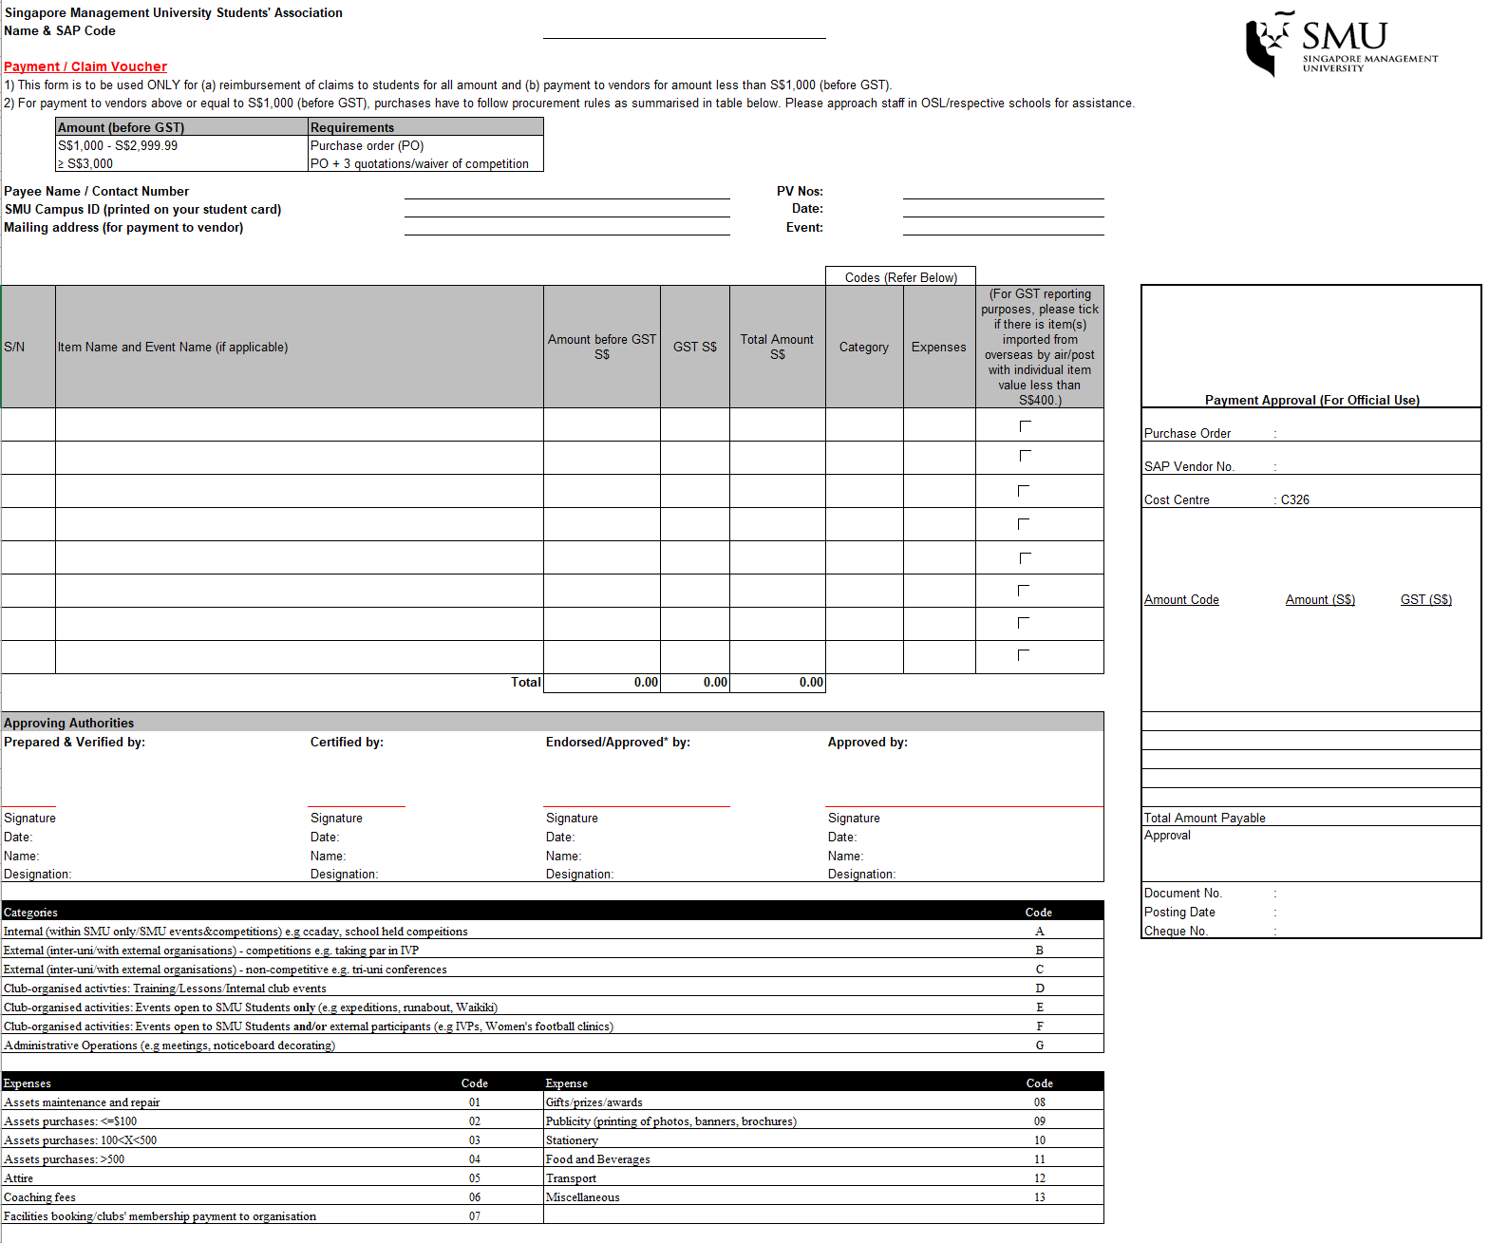
3.6 Payment to Coaches (Annex F2)

This form is to be used by clubs that engage a coach for training (i.e. hiring) and are making a claim for coaching fees.

For hiring of coaches or minibuses for transport of personnel or heavy equipment, please use Annex F.

It is the duty of the Club Executive Committee to ensure that there is prompt submission of this form to the respective CBd FINSEC.

The form is to be signed by the coach at the end of every training session.

The time-sheet section must be filled in and maintained by the club.

Note:

When a new coach is engaged, please provide the following details together with the claim form:

- Name

- NRIC

- Contact Number

- E-mail

- Mailing Address

- Bank Details (Attach a photocopy of Bank Book & Blank Cheque)

This information would be inserted into the OFIN system when paying the coach directly.

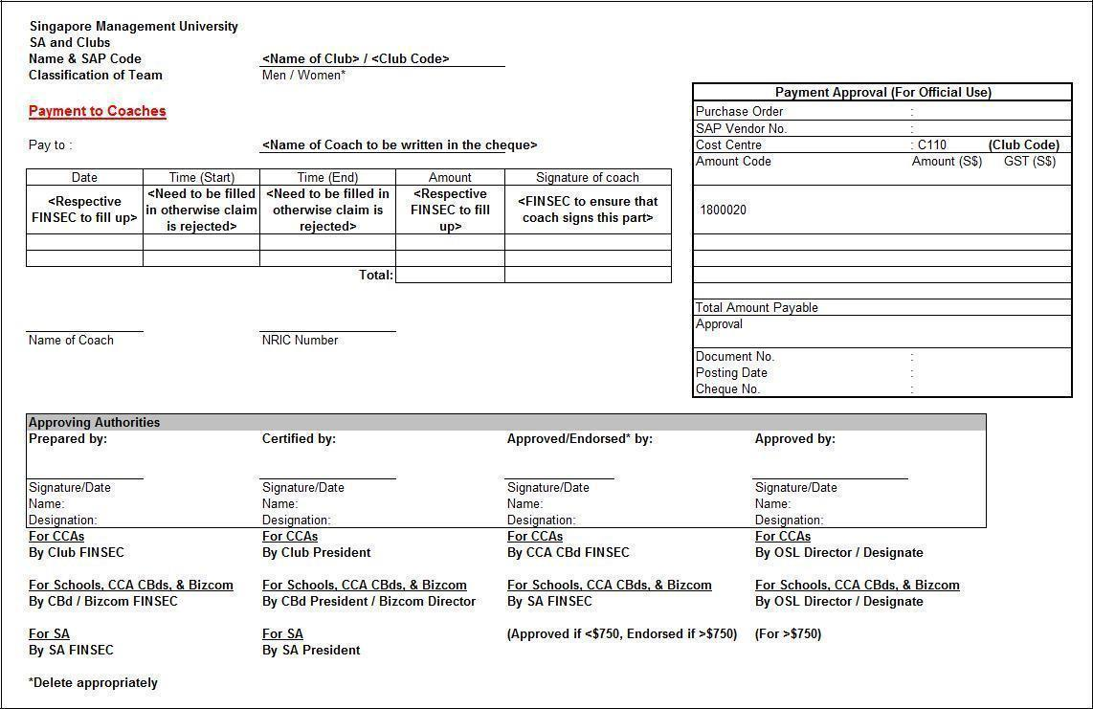

Annex F2

3.7 Transportation

This form is to be used only for transportation claims, and only if a transportation allowance was budgeted for by the club / CBd.

For hiring of coaches or minibuses for transport of personnel or heavy equipment, please use Annex F.

Students on official work (i.e. work requiring collecting heavy items) may seek reimbursement from the clubs according to bus fare or MRT fare rates if they use public transport.

Travel by taxi is only allowed when the student concerned has to carry bulky items from one place to another for official reasons (i.e. heavy equipment, tools, trophies, etc.).

For taxi receipts, a photocopied version of the receipt should also be supplied.

Students are not allowed to rent motor vehicles for official work. Only goods vehicles or minibuses can be hired for transporting goods or ferrying of students.

Students may claim for mileage if they use their private vehicles to transport items (i.e. goods etc.) for official school activities.

Official receipts (original) must be attached to the Transport Form.

4. Documentation of Financial documents for student clubs

(W.E.F Jan 2020)

All CBds and student clubs are to retain scanned copies of all documentation pertaining to cash inflows & outflows and store them in an orderly manner.

List of documents to be kept include, but not limited to the following:

- Supporting documentation should be retained for all forms of revenue, regardless of the source and nature. Supporting documentation could be in the form of cash receipts, email correspondences, agreements, commitment letters, invoice, etc. These supporting documents should specify the Association, Ex-Co, CBd or Club name, date of the cash receipt, description of payment received with authorized signatory, if required.

- Supporting documentation should be retained for all forms of Expenses, regardless of the source and nature. Supporting documentation could be in the form of cash receipts, quotations,) and invoice, etc.

- All supporting documentation are required to be retained for three calendar years for audit purposes.

Auditing

FACT Audit
Full audit by Financial Advisory and Compliance Team (FACT) – include comprehensive examination of Revenue, Expenses and Asset matters. As per SMUSA Financial guidelines.

FACT updates SMUSA on the clubs chosen to be audited by FACT, clubs need to comply and send in relevant documents.

Clawback Policy
The component of the student club funds includes the portion of annual fees that are collected from every student (also known as Student Activities Fund, SAF) and those that are sourced from external parties (Sourced Income). In order to justify the portion collected in the annual fees, the guiding principles for the student club funding are as follows:

5.1 Student Activities Fund (SAF)

The SAF is supposed to fund the operation of the club, thus any excess against the operating expenses in any given calendar year will be rolled over into the Accumulated Surplus of SMU.

5.2 Other Sources of Income

The other sources of income are meant to help the club to be self-sustainable in the long run, thus there should not be a case where the student canvass excess funds and do not have any plan on using the funds. In this aspect, the student club funding should not have more than $100,000 at the end of each calendar year. In addition, the funding would be clawed back by the school as Retained Earnings at year end two calendar years after the funding is raised. i.e., if the funding is raised in 2019, it would lapse by 31 December 2021.

SMUSA Receipt Books Standing Order Updated | 21st Feb 2023

SMUSA Receipt Books

A. Receipt Book Standing Order

E-receipt books are issued via email by the SMUSA Deputy Finance Secretary to requesting club and CBd Finance Secretaries.

Please email the following details to a.finance@sa.smu.edu.sg at least 5 WORKING DAYS before your collection:

- Template A – Money Collection and Receipt Request Form

Please follow the procedure listed below to obtain the forms above:

Step 1: Navigate to the Standing Orders & Guidelines page on SMUSA’s webpage. Alternatively, you may click on this link: https://www.smusa.sg/standing-orders-and-guidelines.

Step 2: Scroll to the Finance section and click on SMUSA Financial Forms. This should lead you to a OneDrive where you can find Template A – Money Collection and Receipt Request Form.

Things to Note:

- SMUSA Finance Department holds the right to not entertain any request for receipt book loan not submitted at least 5 working days in advance.

- All receipt details need to be typed and attached when returning the receipt book.

- The SMUSA Receipt Books should only be requested and collected by the CBd/CCA FINSECs or President, subjected to extraordinary exceptions.

- The SMUSA receipt books are considered highly sensitive financial documents. All clubs/societies must pay their due diligence to ensure that the integrity of the SMUSA receipt books is not compromised in any way.

- The maximum loan period for a receipt book is 4 months from the date of loan.

- If in any case, it is found that any club/society is found to be inappropriately issuing out the official SMUSA receipts, the person and club/society will be severely dealt with according to the penalty system highlighted in B. Please follow the procedure list below during your return:

Step 1: During/after fee collection, do fill up the SMUSA Official E-Receipts (which will be sent via email by the SMUSA Deputy Finance Secretary upon approval of Receipt Book Loan) with the details for each recipient (you would have to duplicate it to send it to your payees).

Step 2: When you have finished collecting the fees, you have to submit Annex N (Receipts Recording Form) and all E-Receipts (which should be tallied with Annex N), preferably in a zipped file. You can retrieve Annex N from the same link you retrieved the Template A – Money Collection and Receipt Request Form. Alternatively, you may use the link below: SMUSA Finance Forms (as of 2023)

SMUSA Receipt Books Standing Order Updated | 21st Feb 2023

Filling in the receipt:

All blank fields of the receipt MUST be filled in the following format shown below.
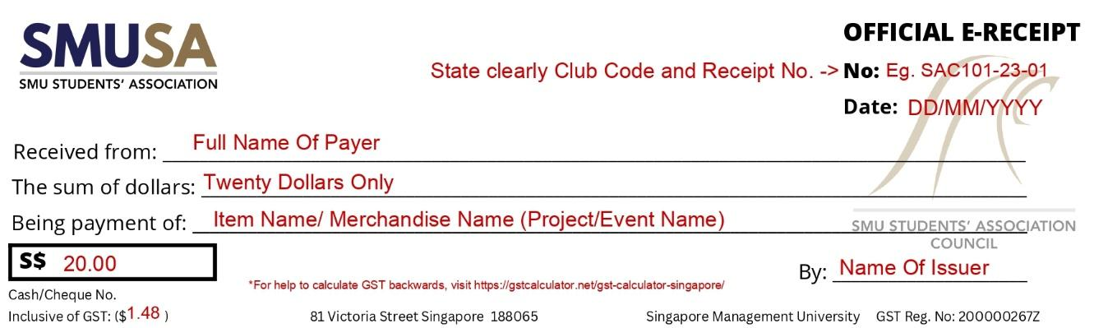
B. Penalty System

The following violations of the standing order will be considered a strike:

- Requests that are submitted less than 5 working days in advance before the intended usage time.
- Template A – Money Collection and Receipt Request Form is not submitted, or is submitted with incomplete information, during the collection of receipt books.
- Annex N, together with a photocopy of the revenue receipt (only for clubs and CBds under SMUSA) is not submitted during the return of receipt books.
- Annex N does not reflect accurately the receipts issued for the event, and the total revenue.
- The requested receipt books are used for more than one event in one loan.
- Receipts are not filled up strictly in the format shown above.
- Annex N is not returned within 2 weeks after the event is completed.

The Receipt Books Standing Order will adhere to one 1 ban cycle of 1st January to 31st December of the ensuing year.

The strike system is as follows:
 | Penalty | Duration
Strike 1 | The strike committed by the club/CBd will be noted down by the SMUSA Finance Department for future reference. A warning email will be sent to the Club/CBd. | With immediate effect.
Strike 2 | The Club/CBd will be imposed a fine of $20 and it will be deducted from the Club/CBd’s CA within 3 working days. | With immediate effect.
Strike 3 | The Club/CBd will be imposed a fine of $25 and it will be deducted from the Club/CBd’s CA within 3 working days. | With immediate effect.
For clubs who exceed 3 strikes, their offences will be brought up to OSL / School Admin for further investigation.

For any queries regarding collection/return of SMUSA receipt books, please email us at: a.finance@sa.smu.edu.sg.

SMUSA Receipt Books Standing Order Updated | 21st Feb 2023

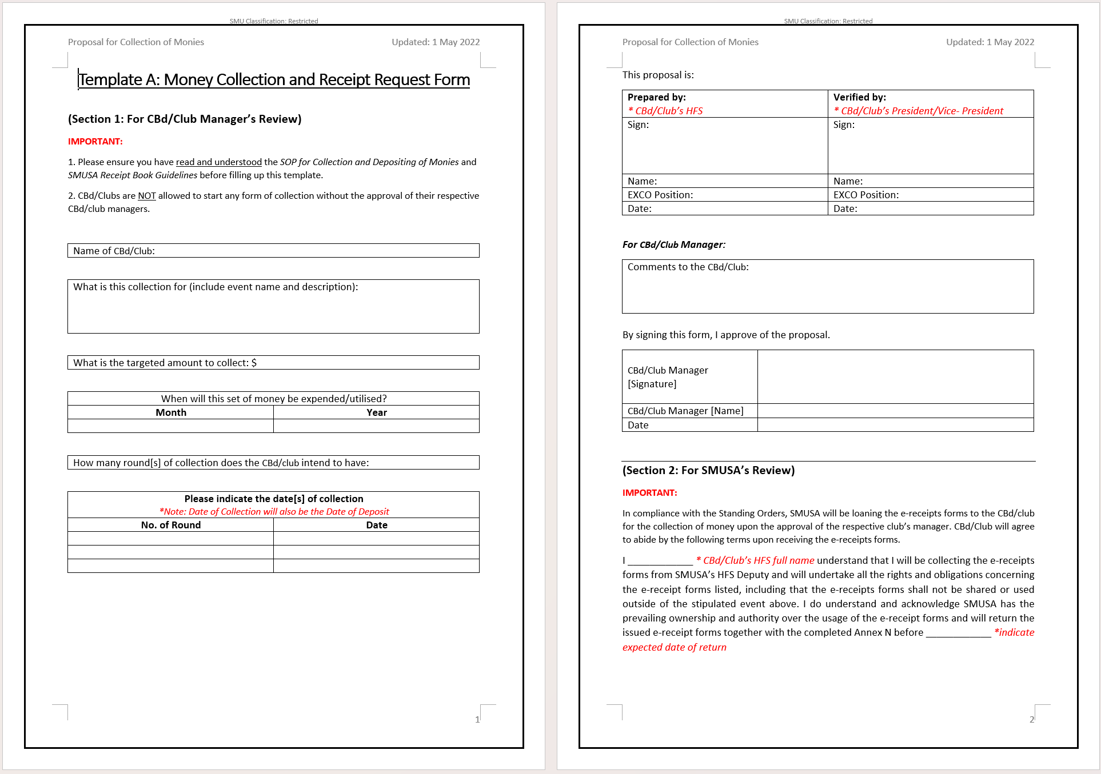
C. SMUSA E-Receipt Refund Policy

Each Club Fin Sec must strictly adhere to the following procedures below when refunding payment of fees to students within the club’s acceptable timeframe.
- On request for refund by student after an e-receipt has already been issued to him/her, update in Annex N accordingly by putting a strikethrough through the student’s name and his/her e-receipt serial number.

- Create a separate spreadsheet inside the excel file Annex N and title it as ‘Refunds’.

- Attach a screenshot of the refund made to the student’s bank account and indicate the reason for refund below the screenshot.

- When sending back the e-receipts in the ZIP file, please do not omit the e-receipt that had been previously issued to the student who requested for the refund. Instead, please include it inside the ZIP file as well and indicate on that particular e-receipt in red ink as ‘Refunded’.

Updated as of 8 February 2023.

8. Budget Endorsement Meeting Standing Order

- Preliminary matter

  - The Finance Committee, pursuant to the SMUSA Constitution Article 9.2.1.1, consists of the Honorary Finance Secretary, the SMUSA Vice-President, the Finance Secretaries of each CBd, the SMU International Connections Finance Secretary, and the deputy Finance Secretary of the SMUSA Executive Committee.

  - The Honorary Finance Secretary of the Finance Committee shall act as Chairman at the Budget Endorsement Meeting of the Finance Committee.

  - No other parties other than the members of the Finance Committee can attend the Budget Endorsement Meeting, except for deputy finance secretaries of each CBd.

  - In case of any discrepancies, disputes, or unforeseen circumstances that may arise, the Honorary Finance Secretary shall have the authority to make decisions, subject to a two-third majority vote of the Finance Committee.

  - No member of the Finance Committee is allowed to leave the room when a budget presentation has started; with the exception of assigned breaks, subject to the
discretion of the Honorary Finance Secretary.

  - Any amendments to the SMUSA Budget Endorsement Meeting Standing Order can only be approved by a two-third majority vote from members of the SMUSA Council after the Budget Endorsement Meeting.

- Timeline and Duration of Budget Endorsement

  - The SMUSA financial year is from 1st January to 31st December, and the budgeting period is split into 2 separate periods a year:
    - Term 1: 1 Jan – 31 July
    - Term 2: 1 Aug – 31 Dec

  - The Budget Endorsement Meeting may be conducted over multiple sittings, which must not last beyond 12 hours each. Each sitting must be conducted anytime between 8am to 10pm.

  - The Honorary Finance Secretary have the discretion to extend the sitting to finish the ongoing round if it has yet to be concluded, subject to a two-third majority vote by the Finance Committee.

- Voting and approval

  - Each member of the Finance Committee shall be entitled to one vote for all budgets except that which he is presenting for.

  - The International Connections Finance Secretary and the SMUSA Deputy Finance Secretary shall have no voting rights.
  - The SMUSA Honorary Finance Secretary has the power to veto but does not participate in the voting process.

  - Except for the Finance Secretary who is presenting the named budget, the members of the Finance Committee shall individually cast their respective votes in a manner prescribed by the Honorary Finance Secretary. The named budget is passed if there is unanimous approval.

  - When all the named budgets have been passed, the finance committee shall individually cast their votes. The overall budget allocation will be considered approved by the finance committee with unanimous approval.

  - If overall budget allocation is not approved by the finance committee then repeat step (a) to (e) but the approval threshold will be reduced to 85%.

  - If overall budget allocation is not approved by the finance committee then repeat step (f) but the approval threshold will be reduced to 75%.

  - If the overall budget allocation does not get 75% votes casted, then repeat step (g) until the overall budget has been finalized.

  - After the finalized budget allocation have been approved by the Finance Committee, they will be subjected to a two-third majority vote by the SMUSA Council.

  - The Honorary Finance Secretary shall thereafter present the finalized budget allocation to the Director of Office of Student Life for endorsement.

  - In the case that the budgets presented do not get the approval of the SMUSA Council or endorsement from the Office of Student Life, another Budget Endorsement Meeting shall be conducted, and the process will be repeated.

9. Appendix: List of School Clubs under C326

CCA Clubs under SMU Student Association
Cost Centre C326
- SMU Ardiente
- SMU Artdicted
- SMU Ballare
- SMU Broadcast & Entertainment
- SMU Caderas Latinas
- SMU Chamber Choir
- SMU Chinese Orchestra
- SMU Eurhythmix
- SMU Funk Movement
- SMU Guitarissimo
- SMU INDANCITY
- SMU Indian Cultural Society
- SMU Ivory Keys
- SMU Komunitas Indonesia
- SMU Literati
- SMU Music Interactive Club
- SMU Persadamu
- SMUSAIC
- SMU Samba Masala
- SMU SoundFoundry
- SMU StageIT
- SMU Stereometa
- SMU Symphonia
- SMU Voix
- SMU Aikido
- SMU Aquathlon
- SMU Aquatic Sharks
- SMU Archery
- SMU Badminton
- SMU Basketball
- SMU Bowling
- SMU Climb Team
- SMU Cuesports
- SMU Dragonboat
- SMU Fencing
- SMU Floorball
- SMU Golf
- SMU Handball
- SMU Judo
- SMU Kendo
- SMU Muay Thai
- SMU Netball
- SMU Rugby
- SMU RunTeam
- SMU Sailing
- SMU Soccer (Men)
- SMU Soccer (Women)
- SMU Softball
- SMU Squash
- SMU Taekwondo
- SMU Tchoukball
- SMU Tennis
- SMU Touch Football (Women)
- SMU Track & Field
- SMU Ultimate Frisbee
- SMU Volleyball
- SMU Wakeboarding
- SMU Windsurfing
- SMU Wushu

- SMUX Biking Team
- SMUX Diving Team
- SMUX Kayaking Team
- SMUX Skating Team
- SMUX Trekking Team
- SMUX Xseed Team

- SMU AIESEC
- SMU Barworks
- SMU Conjunct Consulting
- SMU Debating Society
- SMU E-Sports
- SMU FitnessWorks
- SMU Gourmet Club
- SMU I-Sports
- SMU Mixed Martial Arts
- SMU People for Animal Welfare
- SMU Real Business
- SMU Recreational Fishing
- SMU Strategica
- UN Students’ Association
- SMU Toastmasters
- SMU Verts
- SMU Wine Appreciation Club
- SMU Women's Connection
- Community Service Clubs
- SMU BP Mentoring
- SMU Caretalyst
- SMU Habitat for Humanity
- SMU Red Cross Youth Chapter
- SMU Rotaract Club
- SMU Uni-Y
- Registered Societies
- SMU Apolitical
- SMU Christian Fellowship
- SMU CRU
- SMU Dhamma Circle
- SMU Fides
- SMU Muslim Society
- SMU Sikhs Inc

Arts & Cultural Fraternity
(ACF)
SMU Sports Union
(SSU)
SMU Xtremists
(SMUX)
Special Interest & Community Services Sodality
(SICS)

School Clubs under SMU Student Association
Cost Centre C326

College of Integrative Studies
- inCISive

Lee Kong Chian School of Business
- Bondue

School of Accountancy
- ASoc

School of Computing and Information System
- Ellipsis

School of Economics
- OIKOS

School of Social Sciences
- SOSCIETY

Yong Pung How School of Law
- The BAR

